**Sales Automobile Using Salesforce CRM**

**Project Description:**

The Salesforce CRM implementation for automobile sales streamlines the entire sales process, enhancing efficiency and customer satisfaction. Through this system, sales teams can manage leads, track customer interactions, and automate follow-ups. It enables comprehensive customer profiling, allowing for personalized marketing strategies and targeted campaigns. The platform facilitates inventory management, ensuring real-time updates on available vehicles and their specifications. Integration with marketing tools enables seamless communication and lead nurturing. Additionally, the system provides insightful analytics, empowering decision-making by identifying sales trends and forecasting demand. Overall, the Salesforce CRM for automobile sales optimizes operations, fosters customer relationships, and drives revenue growth within the automotive industry.

**Activity 1: Creating Developer Account:**

We are creating a developer org in salesforce.

1. Go to [https://developer.salesforce.com/signup](https://developer.salesforce.com/signup%20)   
   2. On the sign up form, enter the following   
   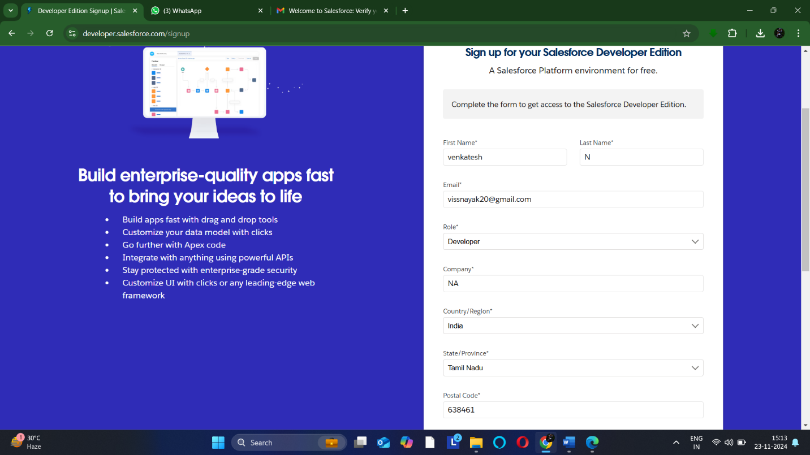  
   details :
2. First name & Last name
3. Email
4. Role : Developer
5. Company : College Name
6. County : India
7. Postal Code : pin code
8. Username : should be a combination of your name and company

This need not be an actual email id, you can give anything in the format :

venkat@developergmail.com Click on sign me up after filling these.

**Activity 2: Account Activation:**

1. After creating the account we open the inbox of the email that you used while signing up. Click on the verify account to activate your account. The email may take 5-10mins.

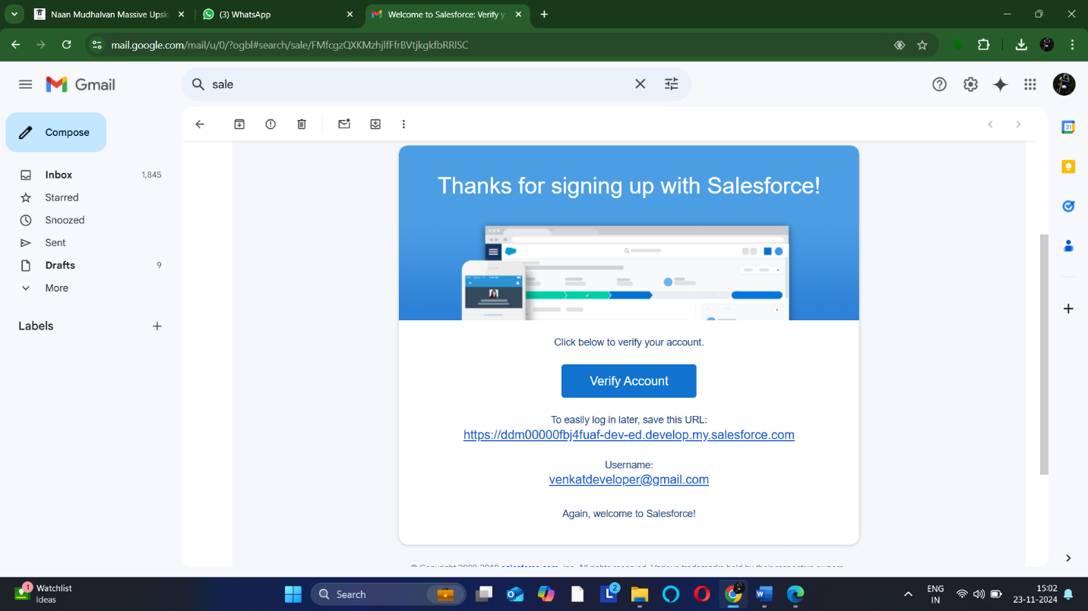

1. Click on Verify Account
2. Creating a new password

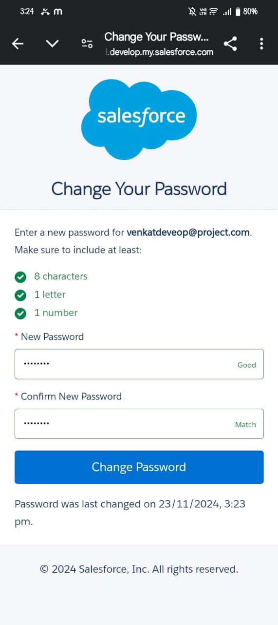

**Activity 1: Create Automobile Information Object**

* 1. We Download and open [this](https://docs.google.com/spreadsheets/d/1Ls-gXLsp8d7ikTJTo5-GlK4AbA4DjZxbFWcj1zKme4I/edit?usp=sharing) [spreadsheet](https://docs.google.com/spreadsheets/d/1Ls-gXLsp8d7ikTJTo5-GlK4AbA4DjZxbFWcj1zKme4I/edit?usp=sharing), save it as AutomobileInformation.csv.
  2. Make sure to download the File into CSV format.

Note : Make sure to have the name of the file as “**Automobile Information**”.

1. Click the Object Manager tab.
2. Click Create.
3. Select Custom Object from Spreadsheet.

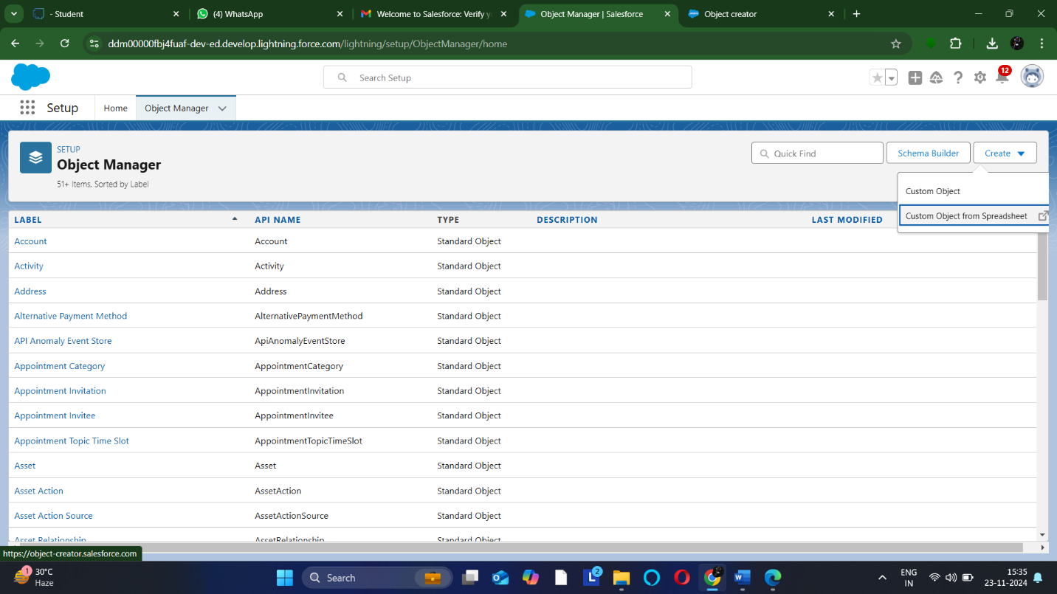

1. Click Login With Salesforce.
2. Enter your Salesforce account username and password. (which you have created in the Milestone 1, Activity 1)
3. Click Log In.
4. Click Allow.
5. Click Upload.
6. Navigate to the Automobile Information.csv file you downloaded and upload it. Salesforce automatically detects the fields and populates all its record data. Choose the Record Name field and make sure all fields are with the proper datatypes as below as they are.

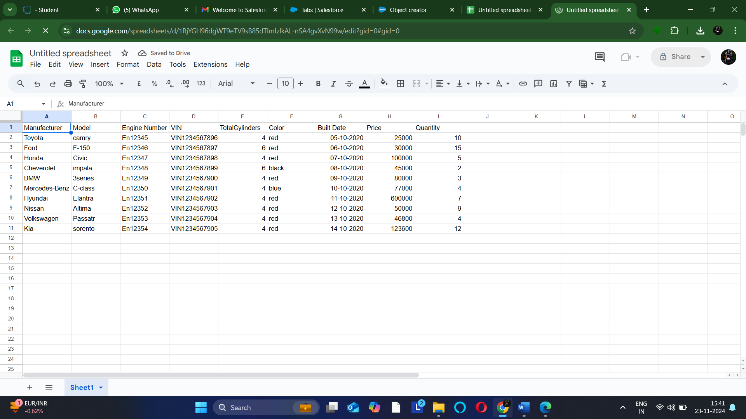

1. Click Next and enter the following settings.
2. Click Finish. The Automobile Information object is successfully created and data imported, all within minutes.

**Activity 2: Create Invoice Object.**

Create Invoice object, just as we have created an Automobile Information Object using [this](https://docs.google.com/spreadsheets/d/11C59mo2WsAN5n18mn3zr-O37nJA3WHyHdB582CaFqVE/edit?usp=sharing) [sheet](https://docs.google.com/spreadsheets/d/11C59mo2WsAN5n18mn3zr-O37nJA3WHyHdB582CaFqVE/edit?usp=sharing) Make sure to Download the File into CSV Format.

**Note:** Make sure you do field mapping with proper field type as shown below.

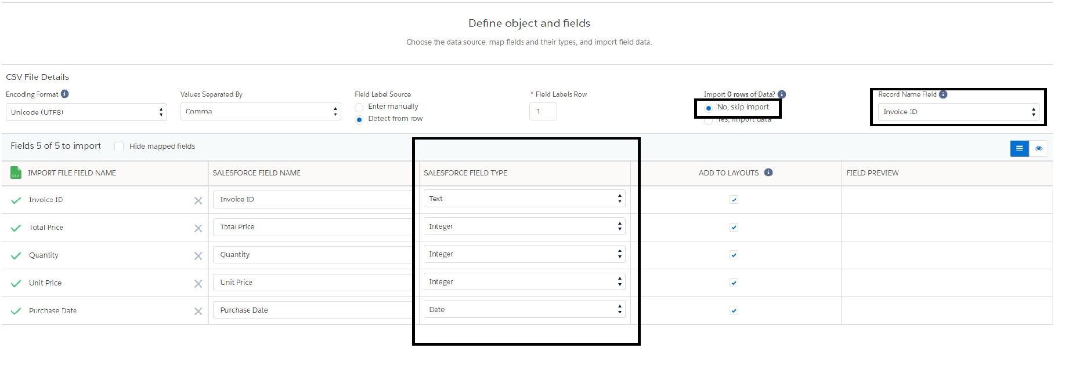

**Activity 3 : Create Automobile Object**

The purpose of creating an Automobile custom object is to store and manage information about Invoice.

**Milestone 3 - Tabs**

**What is Tab:** A tab is like a user interface that is used to build records for objects and to view the records in the objects.

Types of Tabs:

1. **Custom Tabs**

Custom object tabs are the user interface for custom applications that you build in salesforce.com. They look and behave like standard salesforce.com tabs such as accounts, contacts, and opportunities.

1. **Web Tabs**

Web Tabs are custom tabs that display web content or applications embedded in the salesforce.com window. Web tabs make it easier for your users to quickly access content and applications they frequently use without leaving the salesforce.com application.

1. **Visualforce Tabs**

Visualforce Tabs are custom tabs that display a Visualforce page. Visualforce tabs look and behave like standard salesforce.com tabs such as accounts, contacts, and opportunities.

1. **Lightning Component Tabs**

Lightning Component tabs allow you to add Lightning components to the navigation menu in Lightning Experience and the mobile app.

1. **Lightning Page Tabs**

Lightning Page Tabs let you add Lightning Pages to the mobile app navigation menu. Lightning Page tabs don't work like other custom tabs. Once created, they don't show up on the All Tabs page when you click the Plus icon that appears to the right of your current tabs. Lightning Page tabs also don't show up in the Available Tabs list when you customize the tabs for your apps.

**Use Case:**

Creating Objects and storing organization’s data is the very first step in the requirements they want. Now to access the stored data by an employee from the organization Admin needs to create Tabs. By designing a dedicated Tab, businesses can improve user experience, simplify navigation, and provide quick access to critical information, enhancing productivity and ensuring efficient utilization of Salesforce's capabilities.

**Activity 1: Creating a Custom Tab**

**To create a Tab:(Opportunity Automobile)**

1. Go to setup page → type Tabs in Quick Find bar → click on tabs → New (under custom object tab)
2. Select Object(Opportunity Automobile) → Select any tab style → Next (Add to profiles page) keep it as default → Next (Add to Custom App) keep it as default → Save.

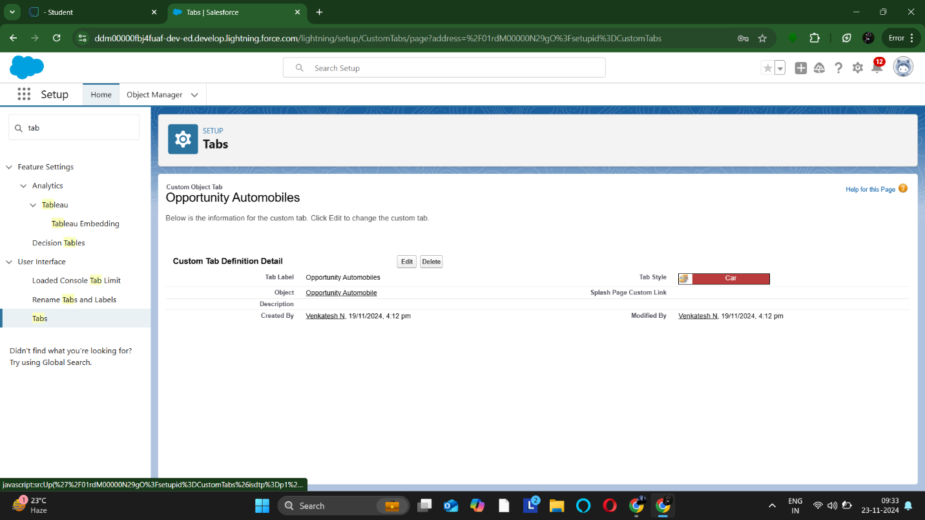

**Note:** Tabs for Automobile Information & Invoice objects do get created automatically. We do not need to create tabs for those objects.

**Milestone 4- The Lightning App:**

An app is a collection of items that work together to serve a particular function. In Lightning Experience, Lightning apps gives users access to sets of objects, tabs, and other items all in one convenient bundle in the navigation bar.

Lightning apps let you brand your apps with a custom color and logo. You can even include a utility bar and Lightning page tabs in your Lightning app. Members of your org can work more efficiently by easily switching between apps.

Use Case:

Well done you have reached close to your organizational requirement by creating the objects to store the organization’s data. Making a database for an organization is just not enough to reach out the requirements, the task is how the users at the organization can access the objects you have created for them. As an Admin for the organization it's your duty to make sure every user of the organization is able to access the data modeling structure.

**Activity 1: Create a Lightning App**

1. We are going to setup page → search “app manager” in quick find → select “app manager” → click on New lightning App.

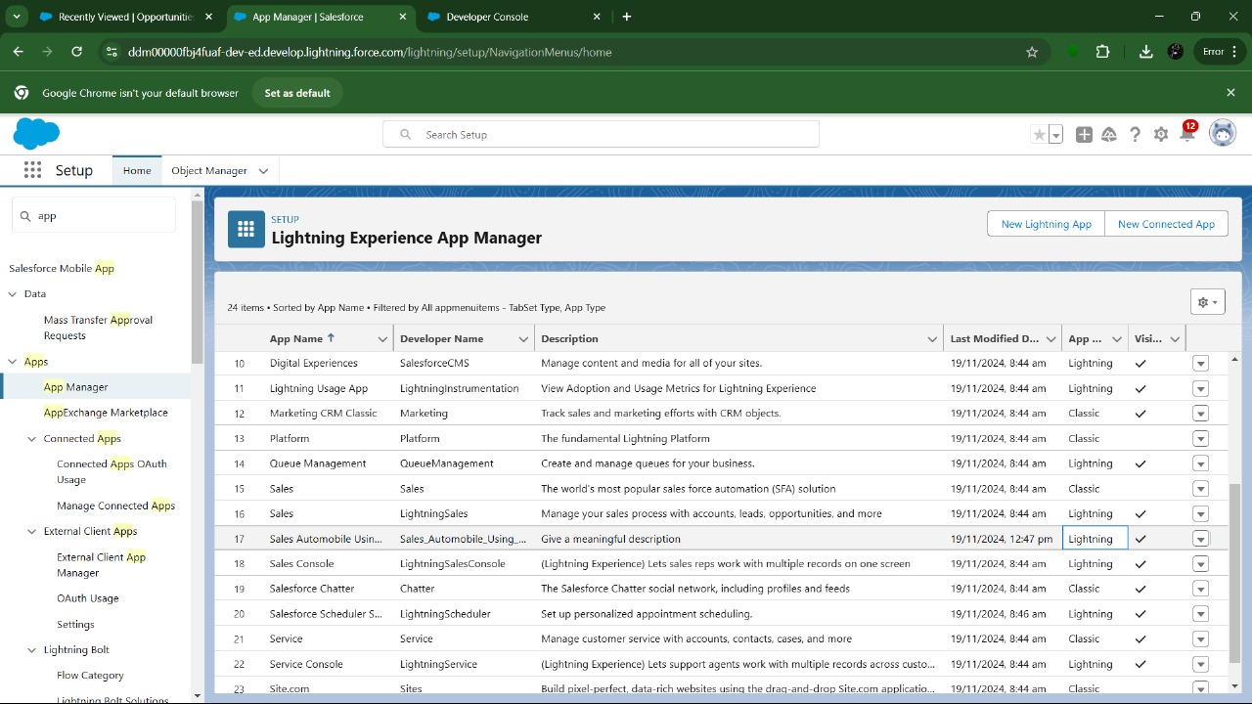

1. Fill the app name in app details and branding as follow
   1. App Name :Sales Automobile Using Salesforce CRM
   2. Developer Name : this will auto populated
   3. Description : Give a meaningful description
   4. Image : optional (if you want to give any image you can otherwise not mandatory)
   5. Primary color hex value : keep this default
2. Then click Next → (App option page) keep it as default → Next → (Utility Items) keep it as default → Next.  
   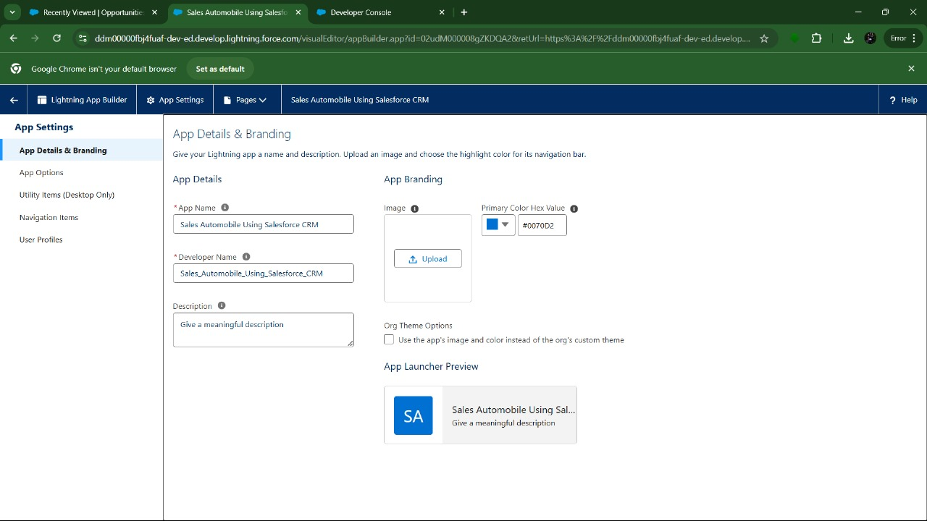
3. To Add Navigation Items:

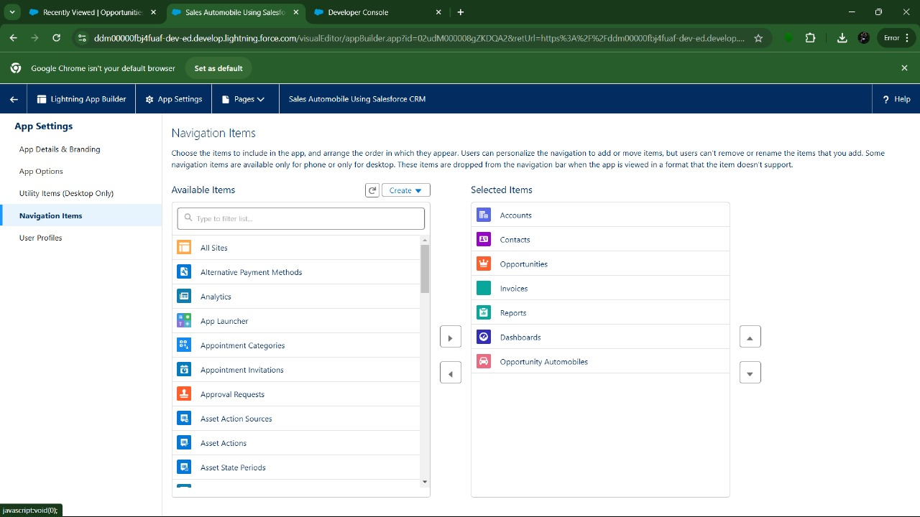

1. Search the items in the search bar(Account,Contact ,Opportunities,Automobile

Information,Opportunity Automobile,Invoice, Reports, Dashboard) from the search bar and move it using the arrow button → Next.

**Note**: select asset the custom object which we have created in the previous activity.

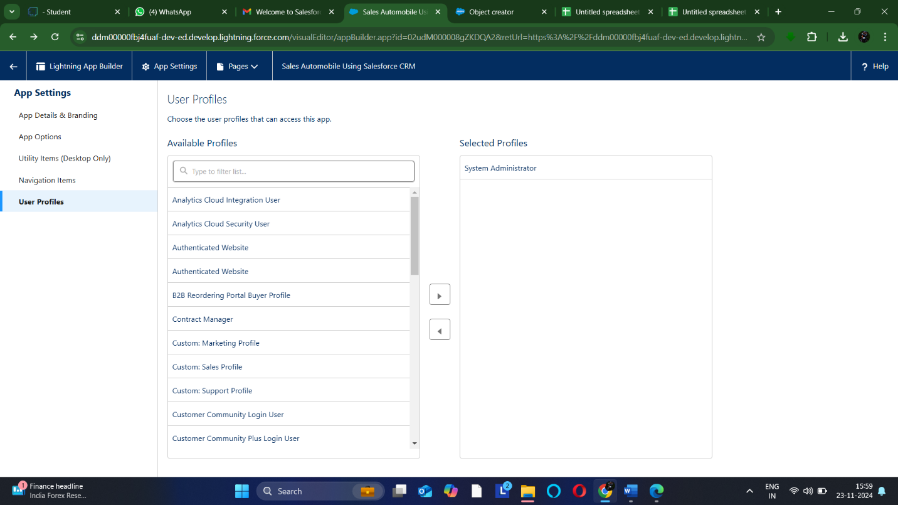

1. Search profiles (System administrator) in the search bar → click on the arrow button → save & finish.

**Milestone 5:Fields & Relationships**

When we talk about Salesforce, Fields represent the data stored in the columns of a relational database. It can hold any valuable information that you require for a specific object. Hence, the overall searching, deletion, and editing of the records become simpler and quicker.

**Types of Fields**

1. Standard Fields
2. Custom Fields

**Standard Fields:**

As the name suggests, the Standard Fields are the predefined fields in Salesforce that perform a standard task. The main point is that you can’t simply delete a Standard Field until it is a non-required standard field. Otherwise, users have the option to delete them at any point from the application freely. Moreover, we have some fields that you will find common in every Salesforce application. They are,

* Created By
* Owner
* Last Modified
* Field Made During object Creation

**Custom Fields:**

On the other side of the coin, Custom Fields are highly flexible, and users can change them according to requirements. Moreover, each organizer or company can use them if necessary. It means you need not always include them in the records, unlike Standard fields. Hence, the final decision depends on the user, and he can add/remove Custom Fields of any given form.

Use Case:

Now it’s time for you to think out of the box for your organization. You have successfully created the database objects for the organization but now all eyes turn on you as you have to define what sort of information the objects store which you have created. As a life saver of your organization you come up with the idea of creating fields to store different types of data.

1. Select Data type as “Master Details Relationship”.

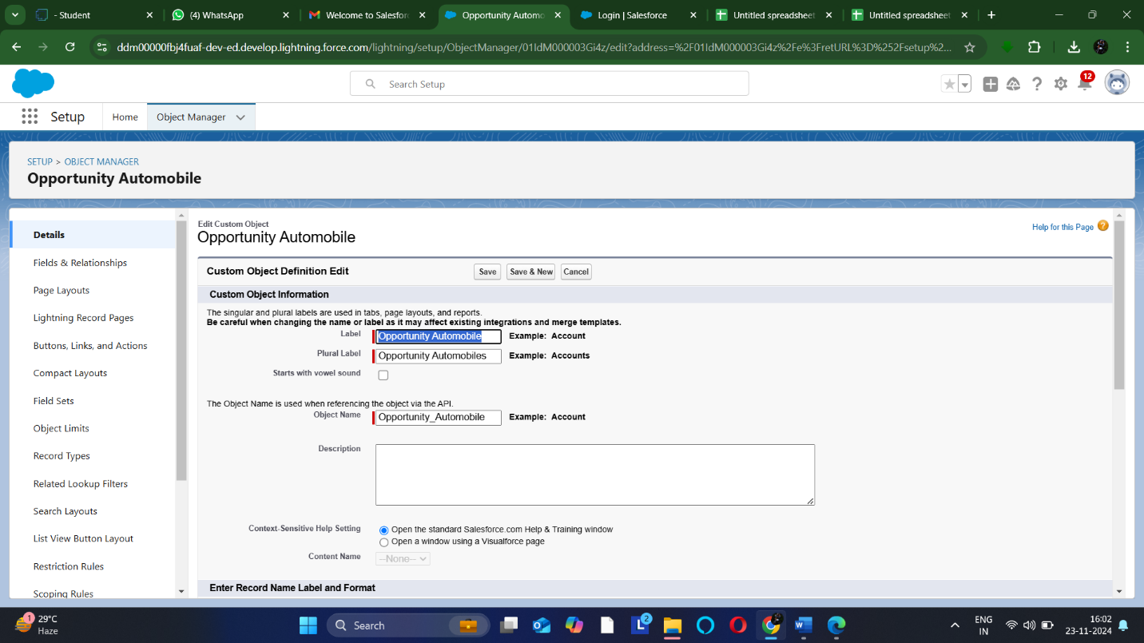

1. Click on Next
2. Fill the above as following:

**Activity 2 : Creating the AutoMobile Information Lookup Field in Opportunity Automobile Object**

To create fields in an object:

1. Go to setup → click on Object Manager → type object name(Opportunity Automobile) in quick find bar→ click on the object.

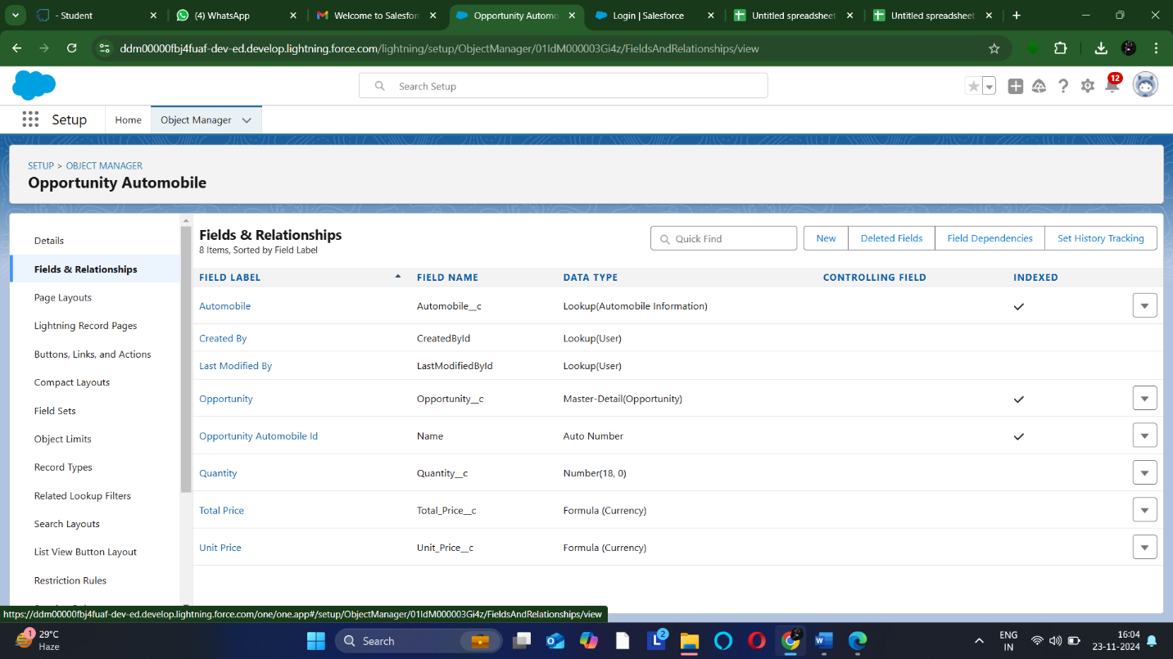

**Activity 3: Creating Quantity Number Field in Opportunity Automobile Object**

To create fields in an object:

* 1. Go to setup → click on Object Manager → type object name(Opportunity Automobile) in quick find bar→ click on the object.
  2. Now click on “Fields & Relationships” → New.
  3. Select Data type as “Number” and click Next.

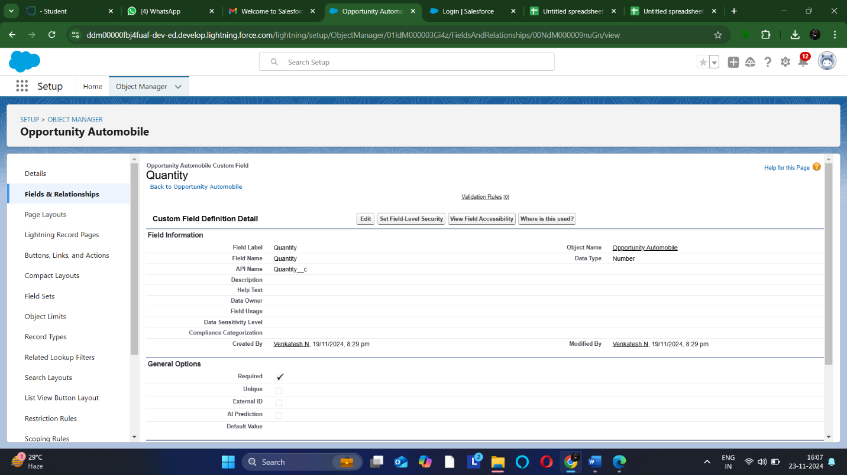

* + 1. Field Label → Quantity
    2. Field Name→ Quantity

**Activity 4 : Creating Formula Field in Opportunity Automobile Object**

To create fields in an object:

1. Go to setup → click on Object Manager → type object name(Opportunity Automobile) in quick find bar→ click on the object.

1. Now click on “Fields & Relationships” → New.
2. Select Data type as “Formula” and click Next.
3. Give Field Label and Field Name as “Unit Price” and select formula return type as “Currency” and change the decimal values to two and click next.
4. 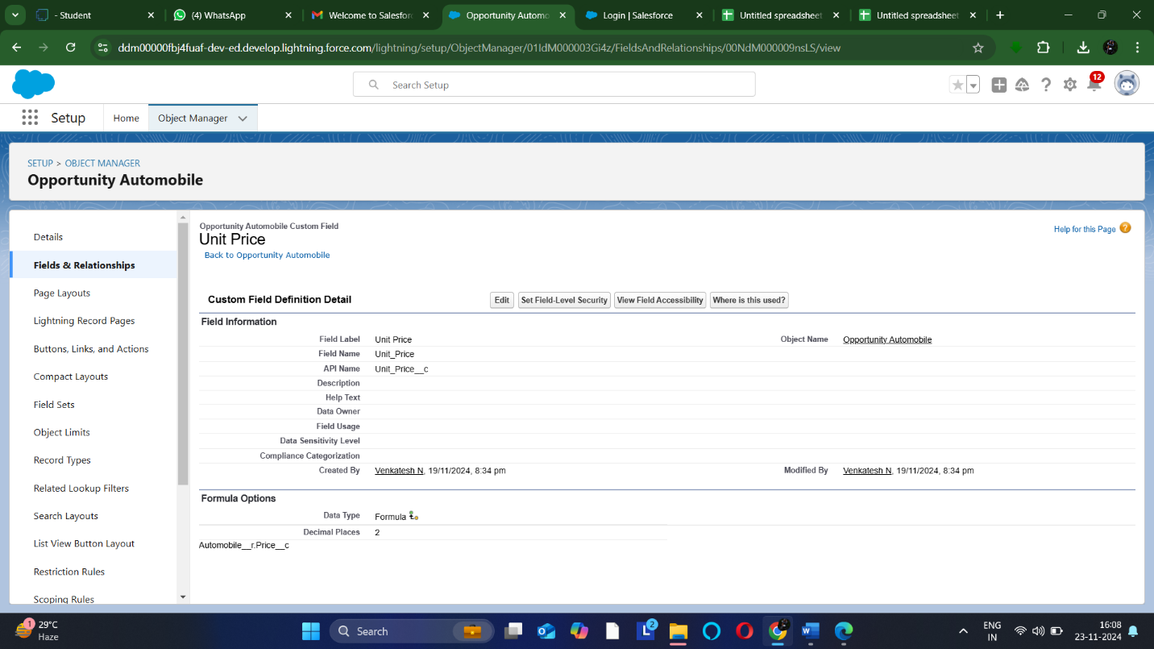
5. Under Advanced Formula write down the formula : **Automobile__r.Price__c**
6. click “Check Syntax” and Next → Next→ Save & New.

**Activity 5 : Creating the Formula field in Opportunity Automobile Object**

To create fields in an object:

1. Go to setup → click on Object Manager → type object name(Opportunity Automobile) in quick find bar→ click on the object.

1. Now click on “Fields & Relationships” → New.
2. Select Data type as “Formula” and click Next.
3. Give Field Label and Field Name as “Total Price” and select formula return type as “Currency” and change the decimal values to two and click next.
4. Under Advanced Formula write down the formula : **Unit_Price__c * Quantity__c**
5. click “Check Syntax” and Next → Next→ Save.

**Activity 6 : Updating field in Invoice Object**

To Update fields in an object:

* 1. we are Going to setup → click on Object Manager → type object name(Invoice) in quick find bar→ click on the object.
  2. Now click on “Fields & Relationships” , Click on the edit of Invoice Id field.
  3. 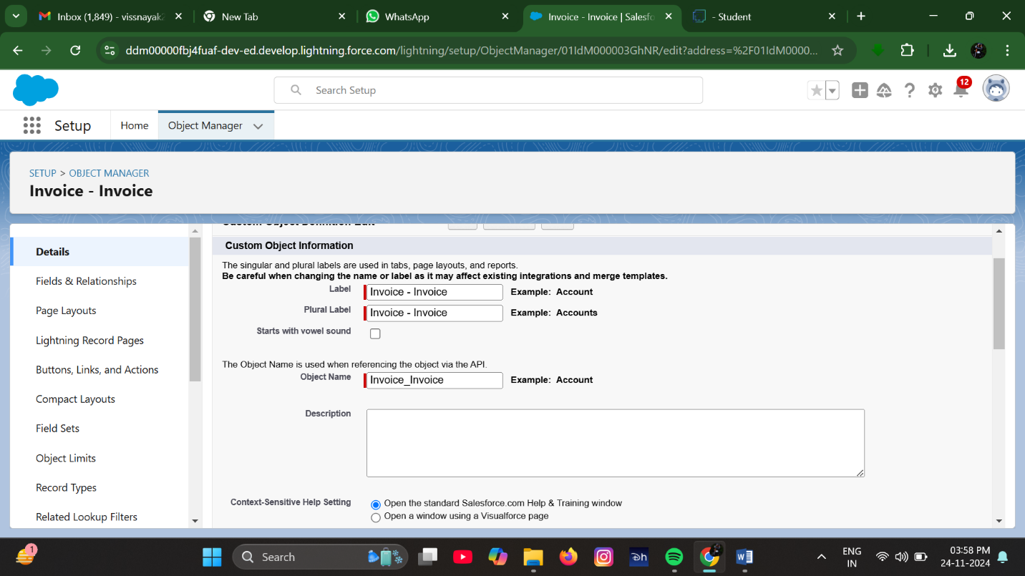
  4. Select Data type as “Auto Number ” and click Next.
     1. Display Format :- I-{0000}
     2. StartingNumber:-
  5. Click Save.

**Milestone 6 : Page Layouts :**

Page Layout in Salesforce allows us to customize the design and organize detail and edit pages of records in Salesforce. Page layouts can be used to control the appearance of fields, related lists, and custom links on standard and custom objects' detail and edit pages.

**Use Case:**

Hurray!! you have completed the data model structure for your organization but while looking at the detailed and edit pages it seems to be so clumsy, so decide to organize the page in a pleasant way for the sake of good and pleasant appearance and assemble all different kinds of information in different sections in order.

**Activity 1: Edit the Page layout for Opportunity Object**

Step 1: Go to Setup → Click on Object Manager →On the search bar, select Opportunity Layout. You can notice Page Layouts on the left panel

Step 2: Click on Page Layouts, Click on ‘Opportunity Layouts’.

Step 3: In the Opportunity Detail Section, you can see various fields. Go on Account And Click on that Properties icon of Account name Field.

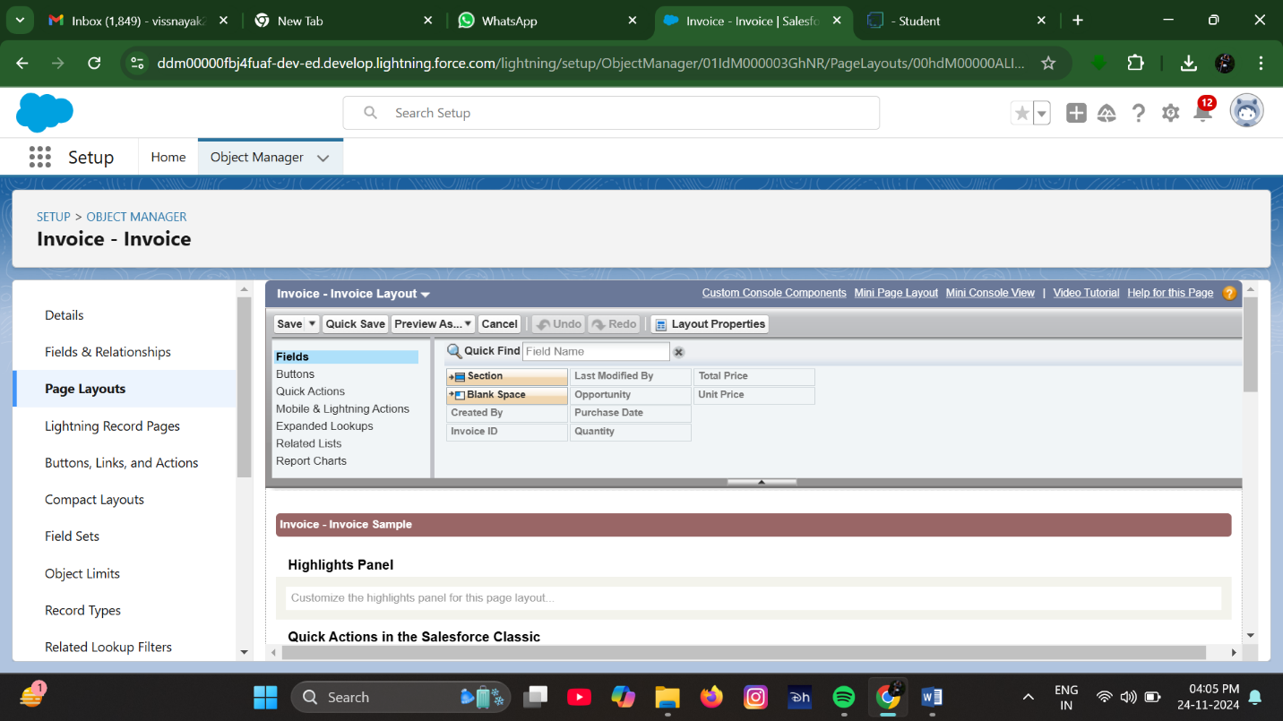

Step 4: check the Required box for Account name and click on Ok.

Step 5: Click on Save.

**Activity 2: Edit the Page layout for Automobiles Information**

Step 1: we are go to Setup → Click on Object Manager →On the search bar, select Automobile Information. You can notice Page Layouts on the left panel

Step 2: Click on Page Layouts. Click on ‘Automobile Information Layout’.

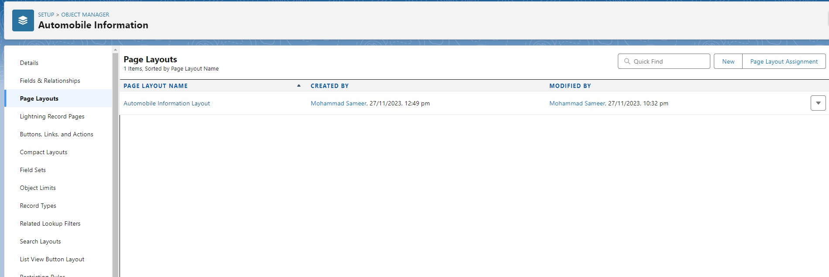

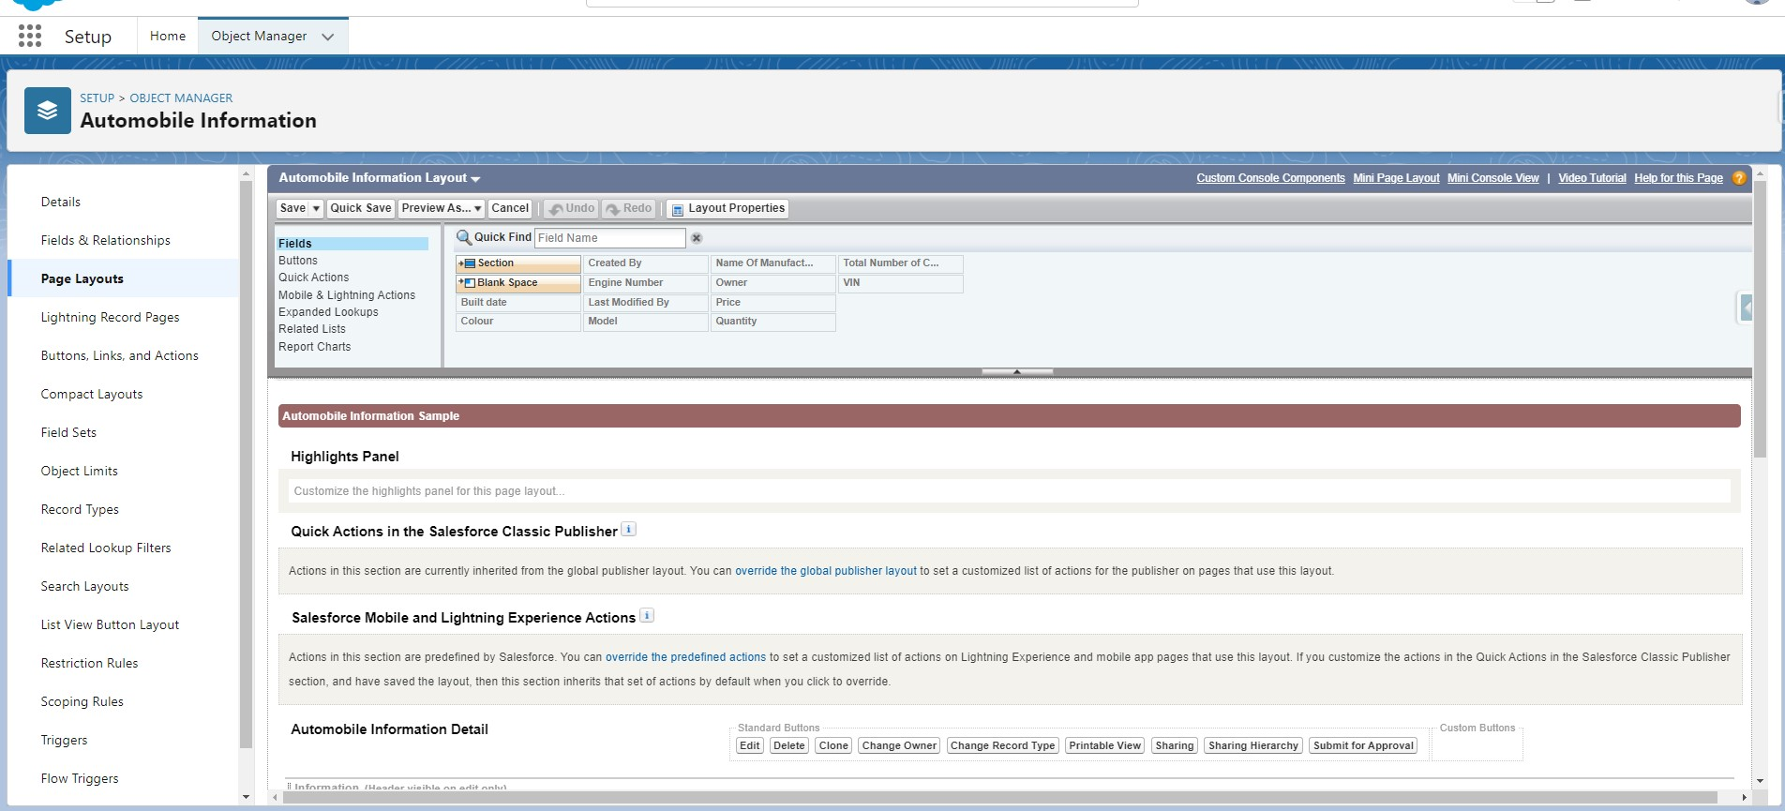

Step 3: Just Go for each one field of Automobile Information Object, Click on Gear Icon and mark as Required just as Done for Above Account Object. After required is done it will show the red color as given in below image.

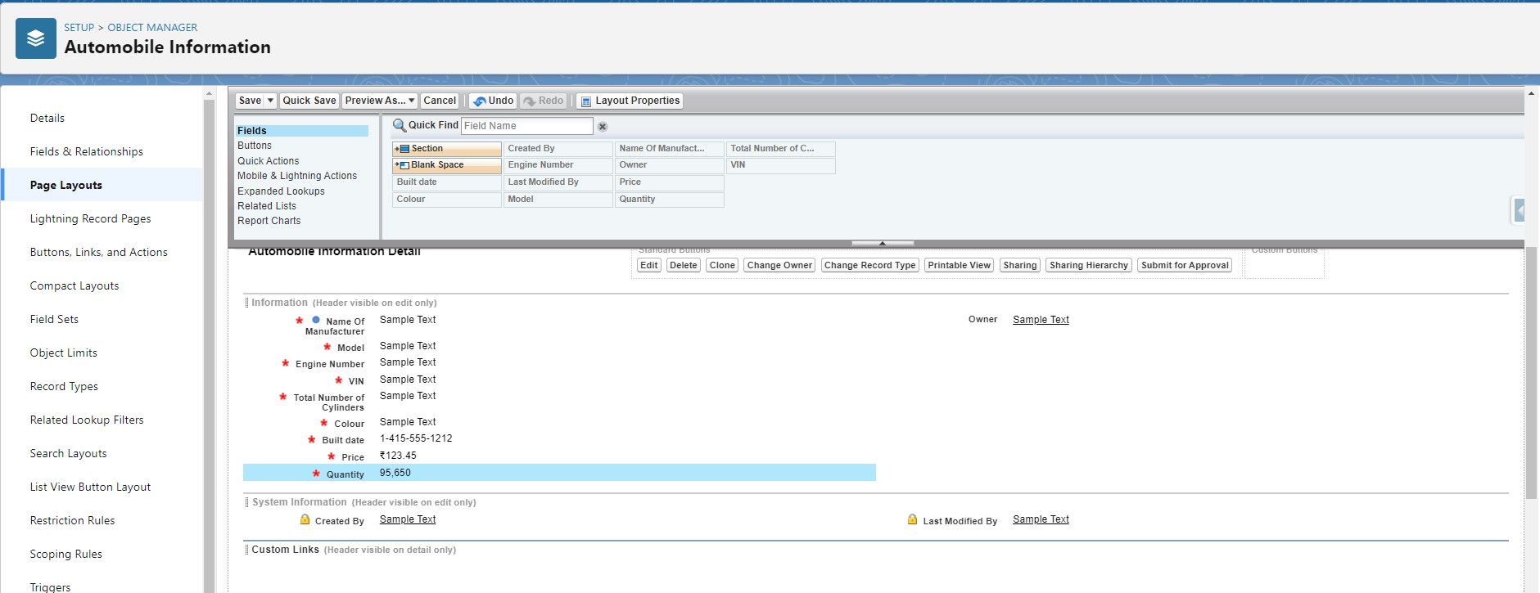

Step 4 : Adjust the Fields as given below for A good looking view.

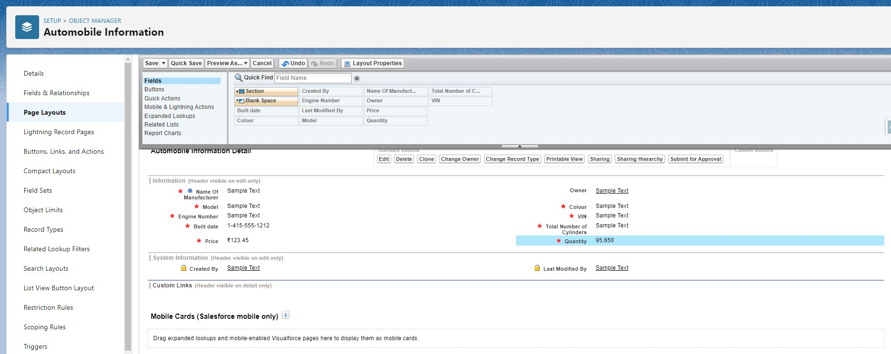

Step 5 : Click on Save.

# Milestone 7: Apex Trigger

Apex can be invoked by using triggers. Apex triggers enable you to perform custom actions before or after changes to Salesforce records, such as insertions, updates, or deletions. A trigger is Apex code that executes before or after the following types of operations:

* insert
* update
* delete
* merge
* upsert
* undelete

For example, you can have a trigger run before an object's records are inserted into the database, after records have been deleted, or even after a record is restored from the Recycle Bin.

You can define triggers for top-level standard objects that support triggers, such as a Contact or an Account, some standard child objects, such as a CaseComment, and custom objects. To define a trigger, from the object management settings for the object whose triggers you want to access, go to Triggers.

There are primarily two types of Apex Triggers:

**Before Trigger:** This type of trigger in Salesforce is used either to update or validate the values of a record before they can be saved into the database. So, basically, the before trigger validates the record first and then saves it. Some criteria or code can be set to check data before it gets ready to be inserted into the database.

**After Trigger:** This type of trigger in Salesforce is used to access the field values set by the system and affect any change in the record. In other words, the after trigger makes changes to the value from the data inserted in some other record.

**Activity- 1:**

**UseCase : Whenever Opportunity Closed won Than Neglect / Minus the Quantity From Automobile Information on the Bases of Opportunity Automobile quantity.**

1. Login to the respective trailhead account and navigate to the gear icon in the top right corner.
2. Click on the Developer console. Now you will see a new console window.
3. In the toolbar, you can see FILE. Click on it and navigate to new and create New apex class.
4. Name the class as “OpportunityHandlerClass ”.

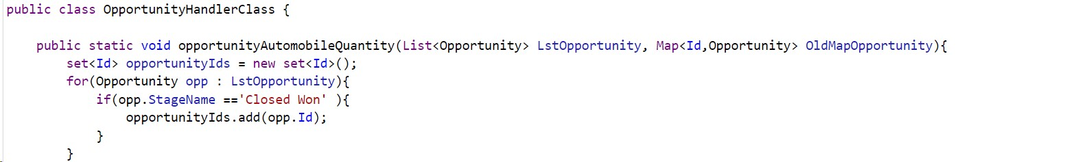

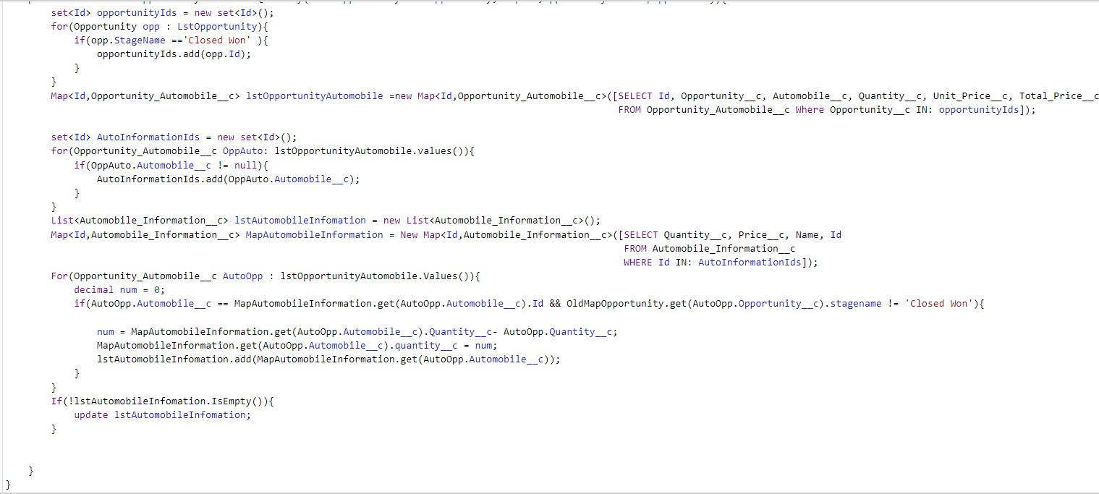

**Trigger Handler :**

**How to create a new trigger :**

1. While still in the account, navigate to the gear icon in the top right corner.
2. Click on developer console and you will be navigated to a new console window.
3. Click on the File menu in the toolbar, and click on new→ Trigger.
4. Enter the trigger name and the object to be triggered.
5. Name : OpportunityTrigger
6. sObject : Opportunity

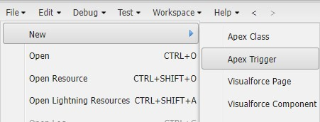

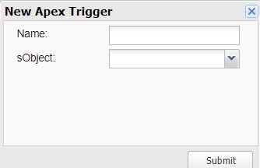

In this project , trigger is called whenever the particular records sum exceed the threshold i.e minimum business requirement value. Then the code in the trigger will get executed.

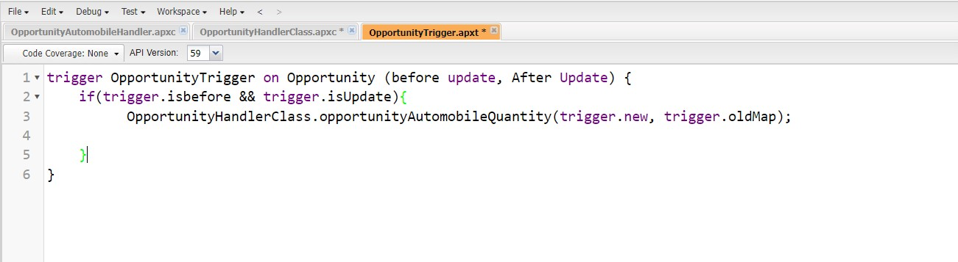

—--------------------------------------------------------------------------------------------------------------**Activity- 2:**

**UseCase : If Quantity of Automobile is Zero or Less than The Quantity from The Opportunity-Automobile Than Throw an error .**

Login to the respective trailhead account and navigate to the gear icon in the top right corner.

1. Click on the Developer console. Now you will see a new console window.
2. In the toolbar, you can see FILE. Click on it and navigate to new and create New apex class.
3. Name the class as “OpportunityAutomobileHandler ”.

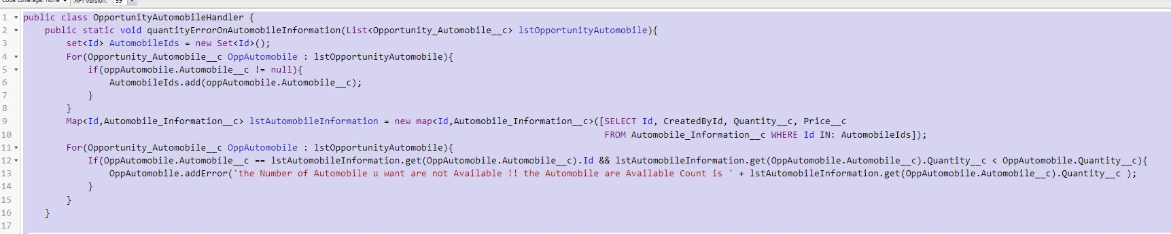





**Trigger :**

Handler for the Opportunity_Automobile__c Object

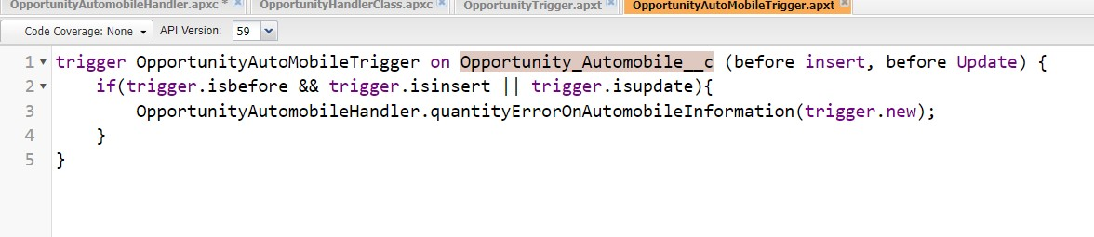

**Activity- 3 :**

**UseCase : Whenever an opportunity is Closed won then create the Invoice on the Bases of Opportunity Automobile Data.**

Login to the respective trailhead account and navigate to the gear icon in the top right corner.

1. Click on the Developer console. Now you will see a new console window.
2. In the toolbar, you can see FILE. Click on it and navigate to new and create New apex class.
3. Name the class as “InvoiceCreation”.

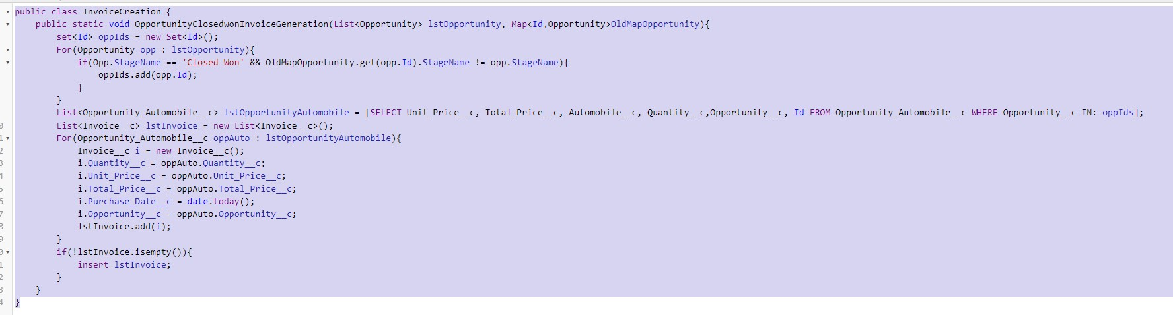

**Trigger Handler :**

For this class we don’t need to create any trigger, we will call this Code in “Opportunity

Trigger”.

1. We are go on files and click on open.
2. Click on triggers.
3. Double click on OpportunityTrigger.

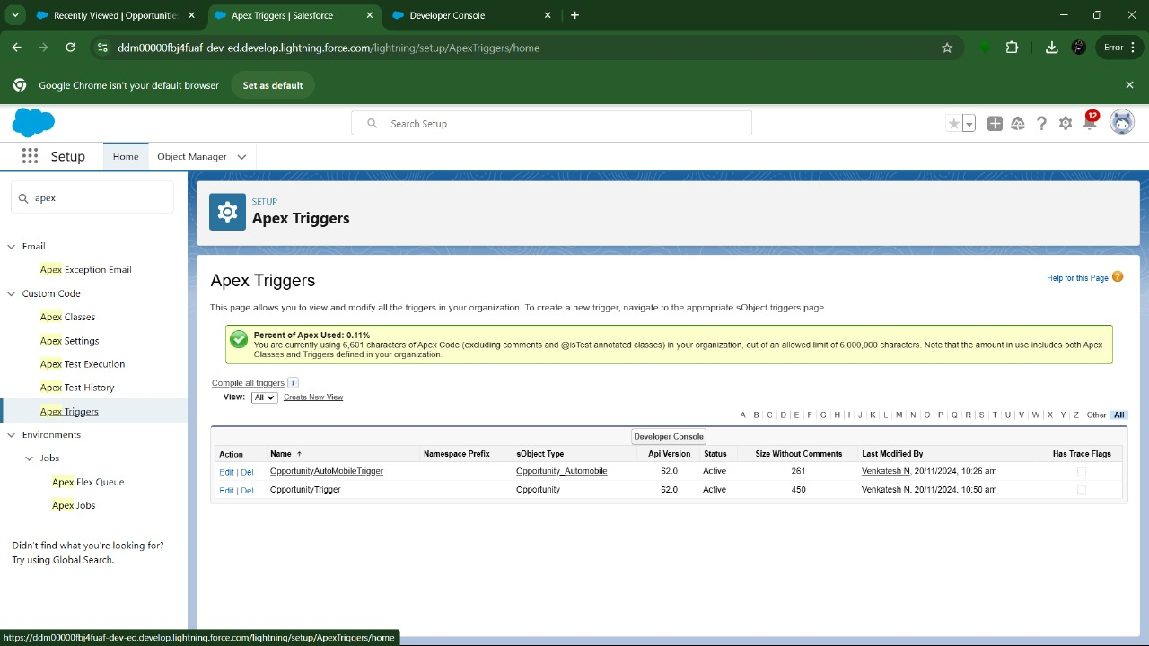

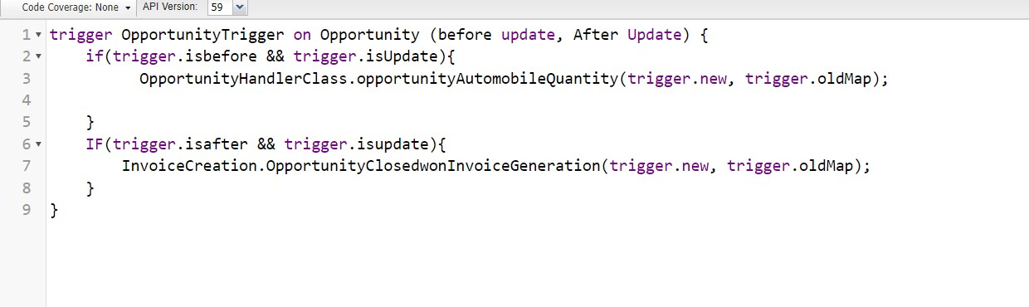

**Activity- 4 :**

**UseCase : Whenever an opportunity is Going to Closed won then check it has the contact role or Not.**

Login to the respective trailhead account and navigate to the gear icon in the top right corner.

1. Click on the Developer console. Now you will see a new console window.
2. In the toolbar, you can see FILE. Click on it and navigate to new and create New apex class.
3. Name the class as “ContactRoleCheck ”.

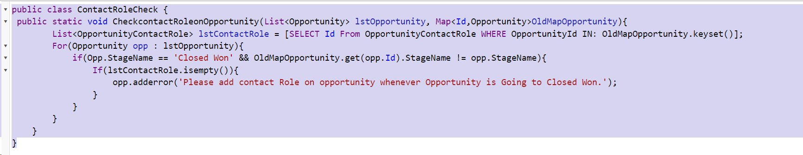

**Trigger Handler :**

For this class we don’t need to create any trigger, we will call this Code in “Opportunity Trigger”.

1. Go on files and click on open.
2. Click on triggers.
3. Double click on OpportunityTrigger.

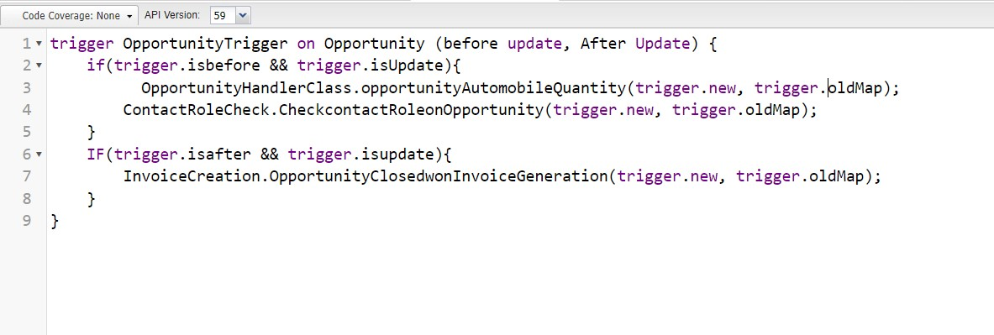

**Trigger:**

**Milestone 8: LWC Component:**

**Activity- 1 : Create Apex Class to Get Invoices**

1. Login to the respective account and navigate to the gear icon in the top right corner.
2. Click on the Developer console.
3. Now you will see a new console window.
4. In the toolbar, you can see FILE.
5. Click on it and navigate to new and create New apex class.
6. Name the class as “OpportunityInvoiceswithLWC ”.

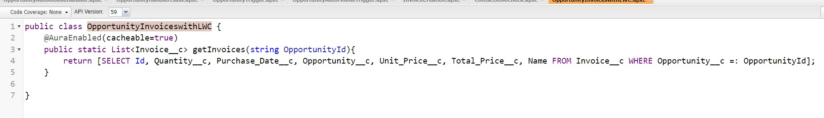

**Activity- 1: Install Salesforce CLI**

The Salesforce CLI is a powerful command line interface that simplifies development and build automation when working with your Salesforce org.

[Download](https://developer.salesforce.com/tools/sfdxcli) [and](https://developer.salesforce.com/tools/sfdxcli) [install](https://developer.salesforce.com/tools/sfdxcli) [Salesforce](https://developer.salesforce.com/tools/sfdxcli) [CLI](https://developer.salesforce.com/tools/sfdxcli)

To confirm that the Salesforce CLI is installed and working correctly, you can open a command prompt and type sfdx. This will display the version number of the Salesforce CLI that is currently installed on your system.

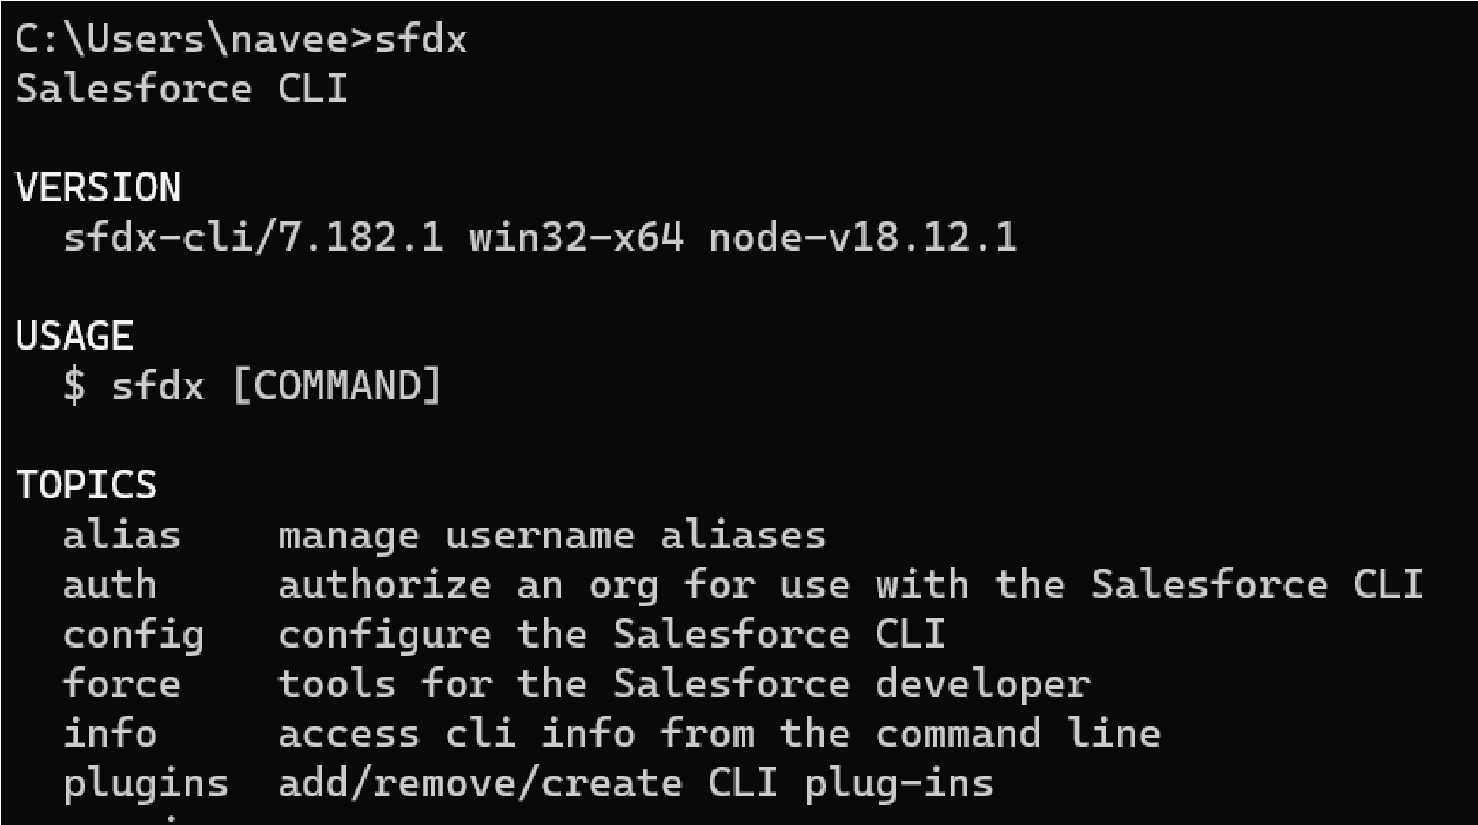

**Activity- 2 : Install Microsoft VS Code**

VS Code, or Visual Studio Code, is a free, open-source code editor developed by Microsoft. It is a lightweight, cross-platform code editor that provides features such as debugging, Git integration, and support for a wide range of programming languages.

[Download](https://code.visualstudio.com/download) [the](https://code.visualstudio.com/download) [version](https://code.visualstudio.com/download) [of](https://code.visualstudio.com/download) [the](https://code.visualstudio.com/download) [software](https://code.visualstudio.com/download) that is compatible with your operating system and install it.

The following instructions are for Windows OS. Other operating systems may have slightly different steps.

**Activity- 3: Install the Salesforce Extension Pack**

In the VS Code,

1. go to extensions (1) as shown in the image below.
2. Search with the Salesforce extension pack (2) as shown in the image below.
3. select Salesforce Extension Pack from the list (3) as shown in the image below.
4. Click the Install button (4) as shown in the image below.

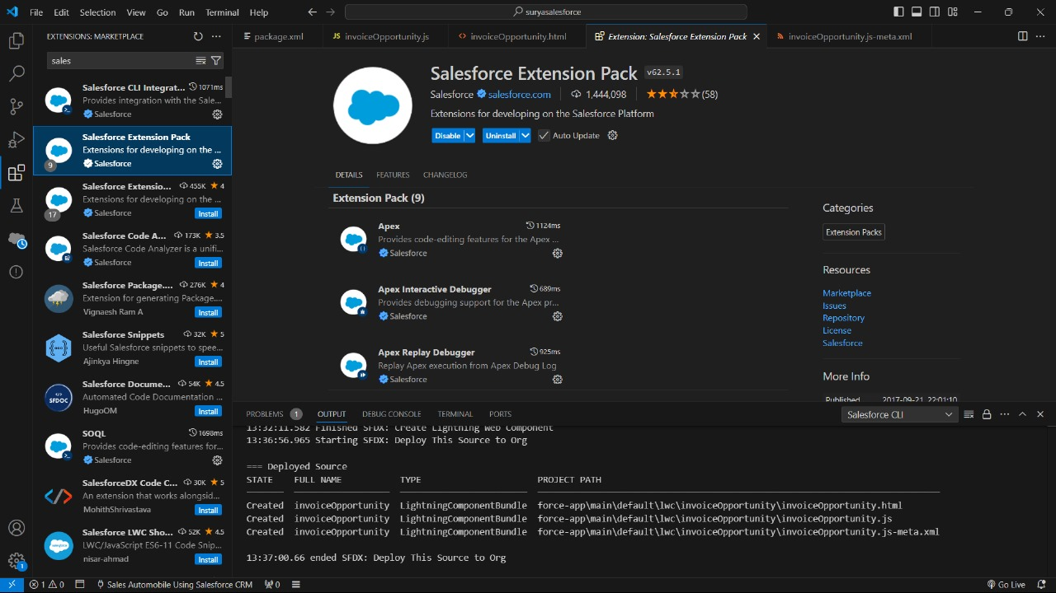

The extension pack is installed successfully

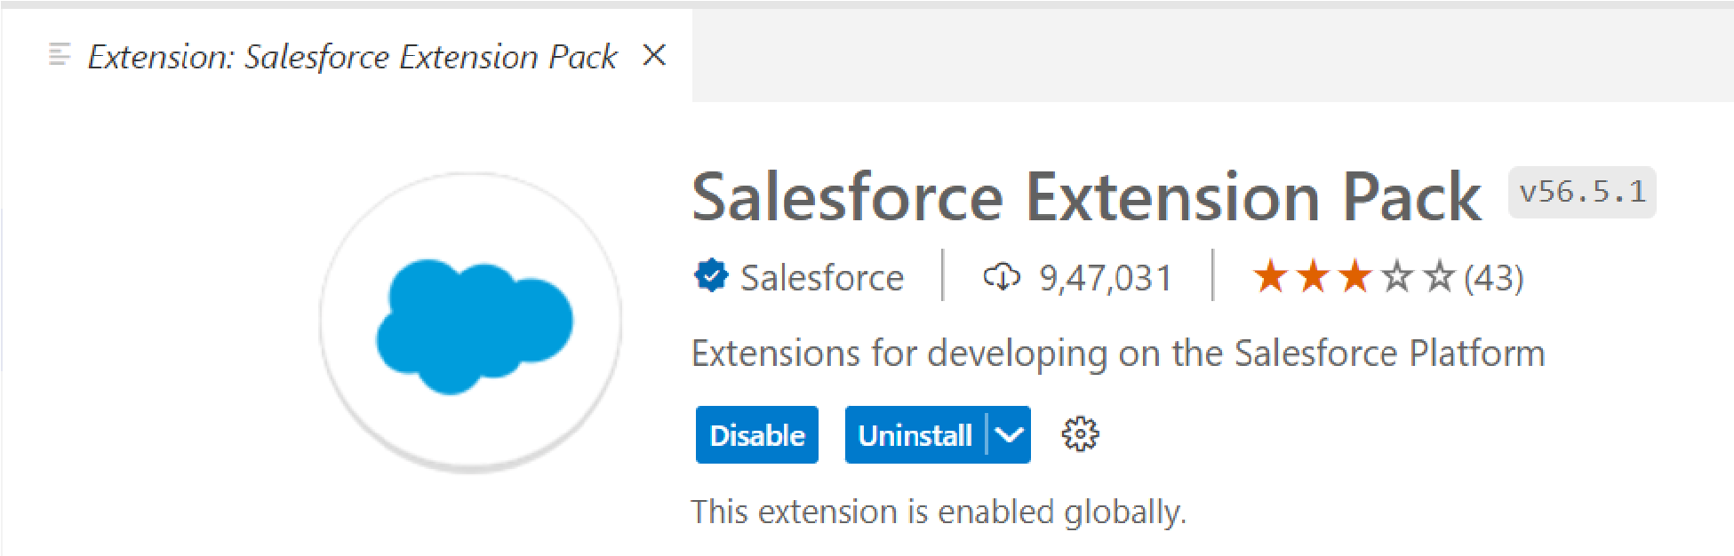

Install the Salesforce Extension Pack

**Activity- 4 : Create a project in VS Code**

1. Press CTRL + SHIFT + P, type sfdx: create
2. select SFDX: Create Project with Manifest

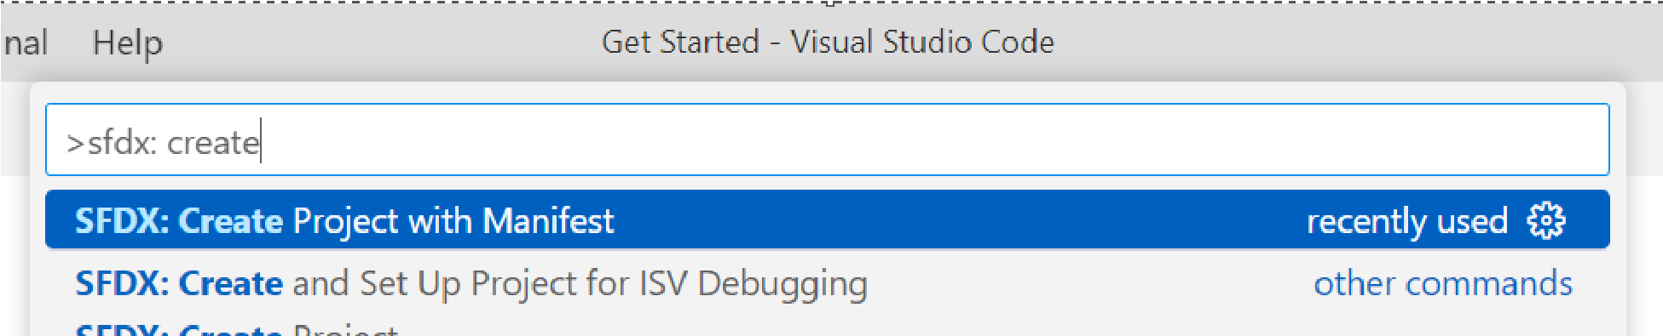

1. Select the Standard project template

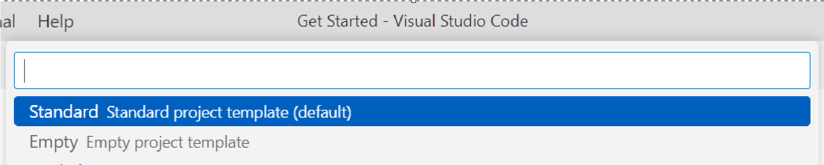

1. Type a project name and Click Enter.

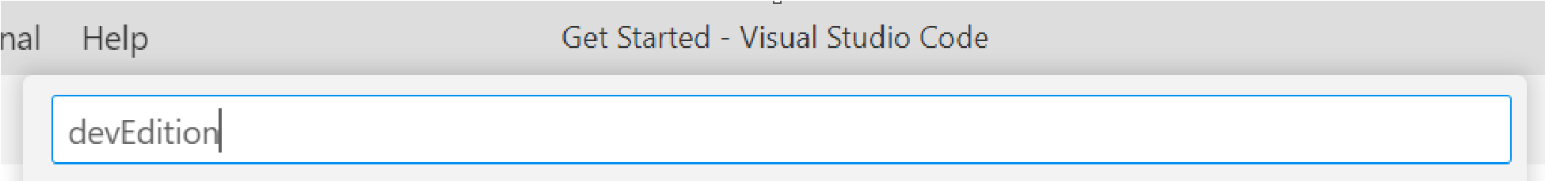

1. Select the folder (create a new folder if required) and click Create Project
2. The new project is created with package.xml

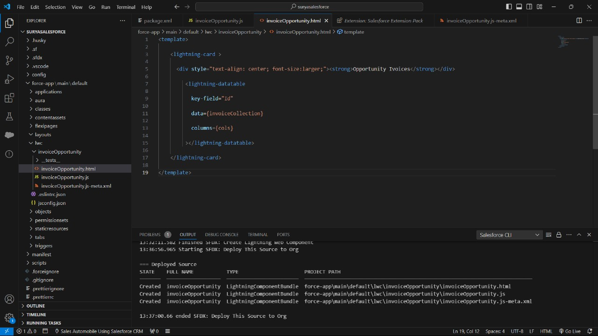

Default Package.xml contains various metadata types. I have updated Package.xml as shown below as we deal only with LWC in this article.

**Activity- 5 : Authorize an org**

Establish a connection between the local project and the Salesforce instance to retrieve and deploy the components.

1. Press CTRL + SHIFT + P, type sfdx: authorize.
2. select SFDX: Authorize an Org from the list
3. Choose your Salesforce instance.

For developer edition and production instances select Production.

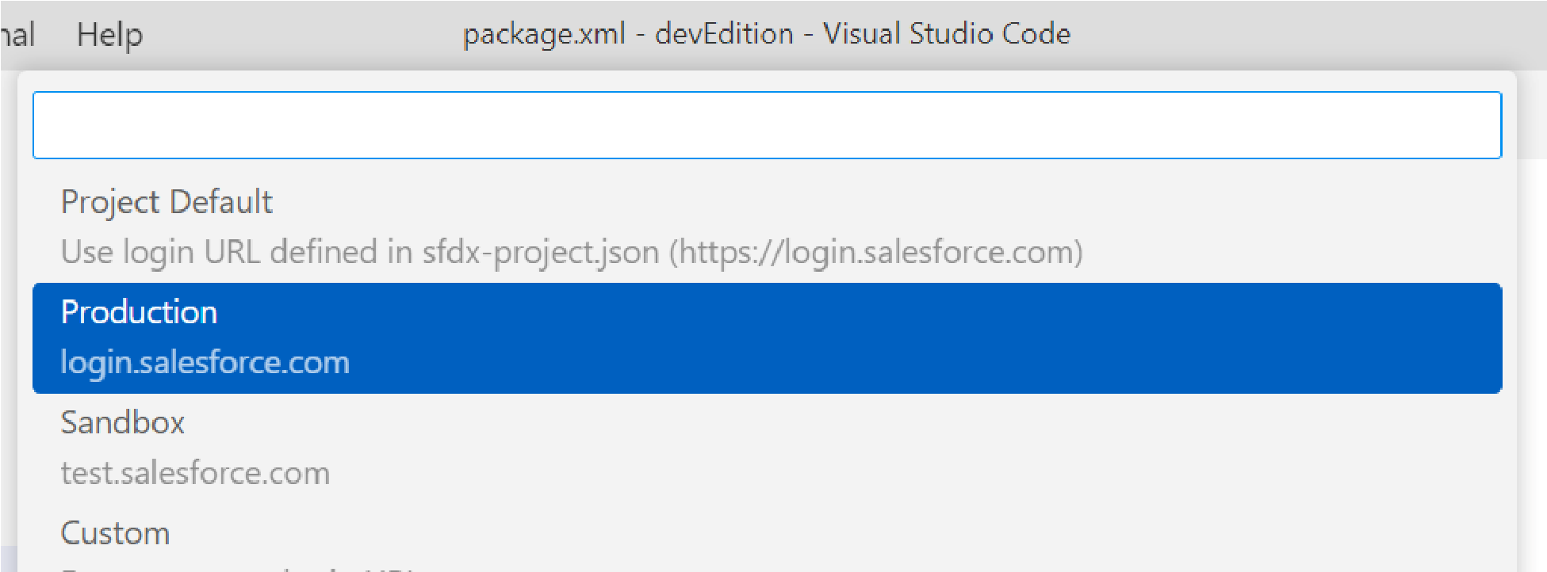

1. For this demonstration, I used the developer edition, hence it is Production.
2. Give a project name and press Enter

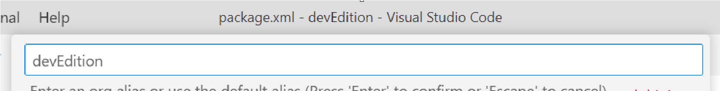

1. The Salesforce login page opens in the browser.
2. Enter the credentials and click Log In

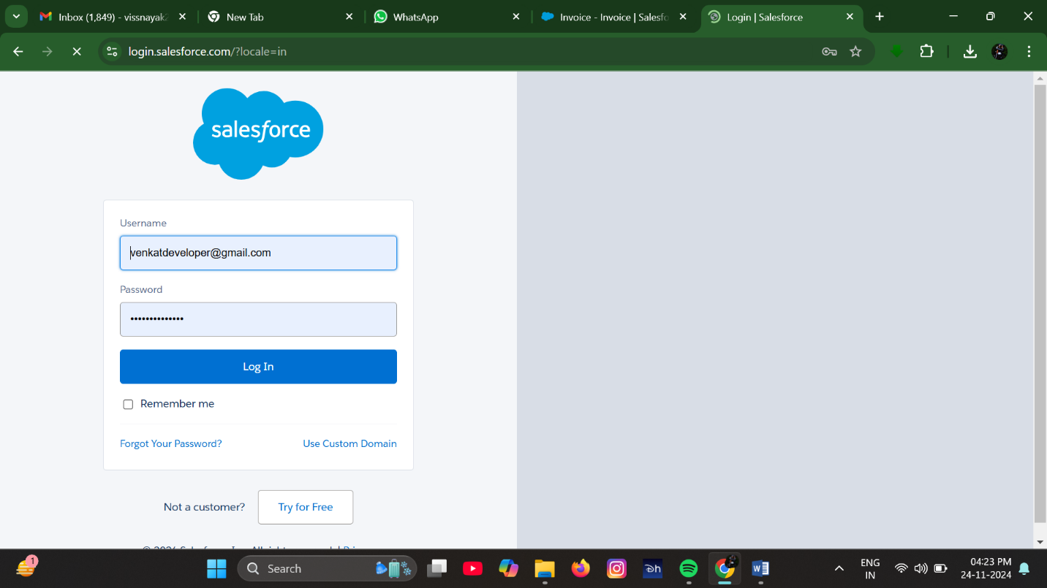

1. It will be successfully authorized.

**Activity- 6 : Create Lightning Web Component**

**XML File :**

1. In the VS Code, press CTRL + SHIFT + P, type sfdx: create lightning in the search bar, and select SFDX: Create Lightning Web Component

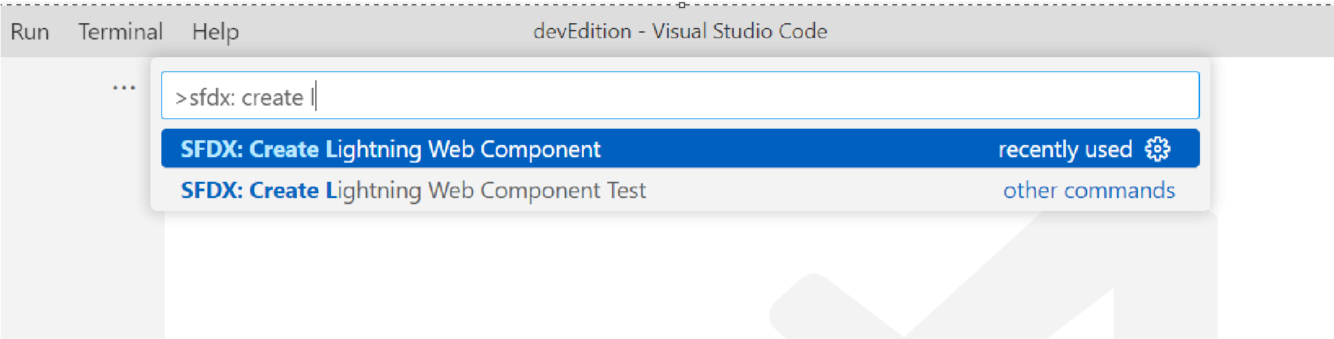

1. Give the name “InvoiceOpportunity” and press Enter.

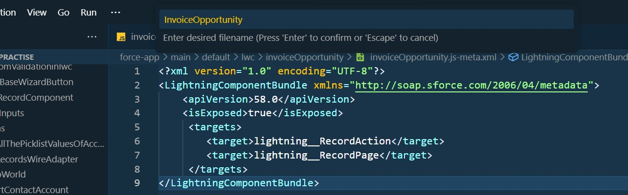

1. Choose the directory.

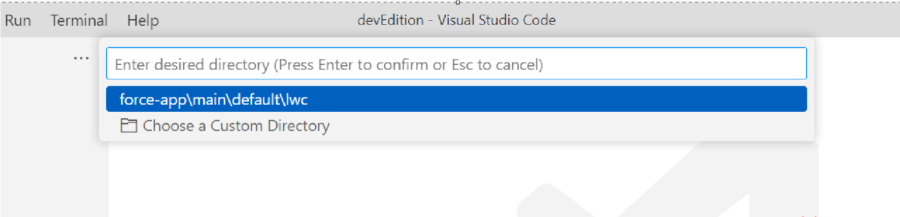

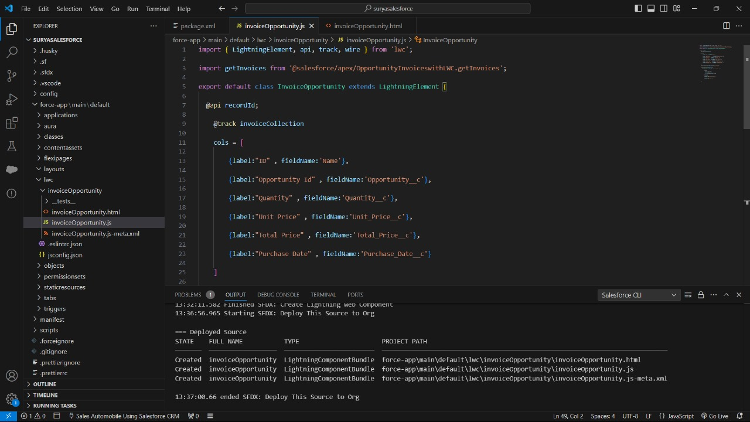

1. Copy and paste the below-mentioned code in the InvoiceOpportunity.js-meta.xml and update the apiVersion tag with the latest API version.

**JS File :**

1. Copy and paste the below-mentioned code in the InvoiceOpportunity.js and update the apiVersion tag with the latest API version.

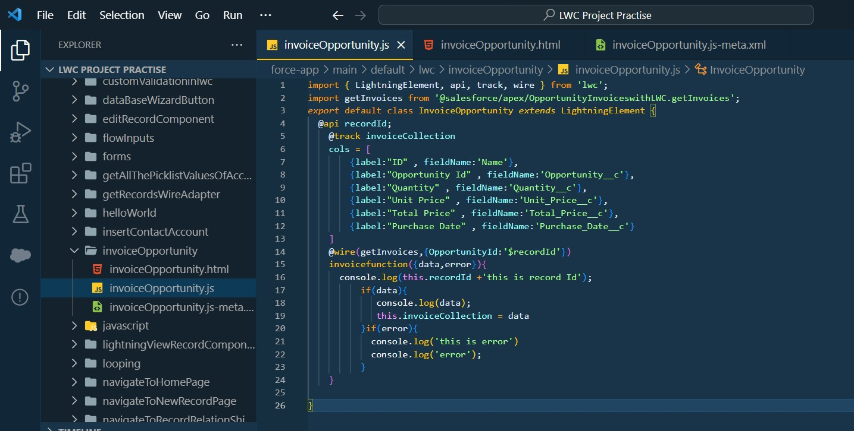

}if(error){ console.log('this is error') console.log('error');

}

}

}

**HTML File :**

1. Copy and paste the below-mentioned code in the InvoiceOpportunity.html and update the apiVersion tag with the latest API version.

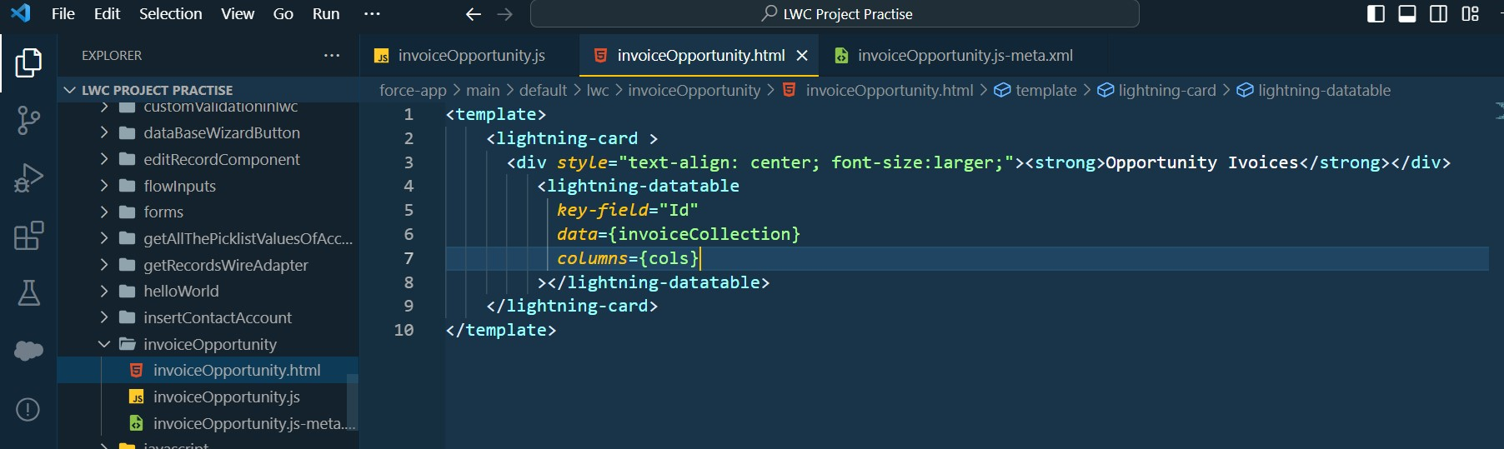

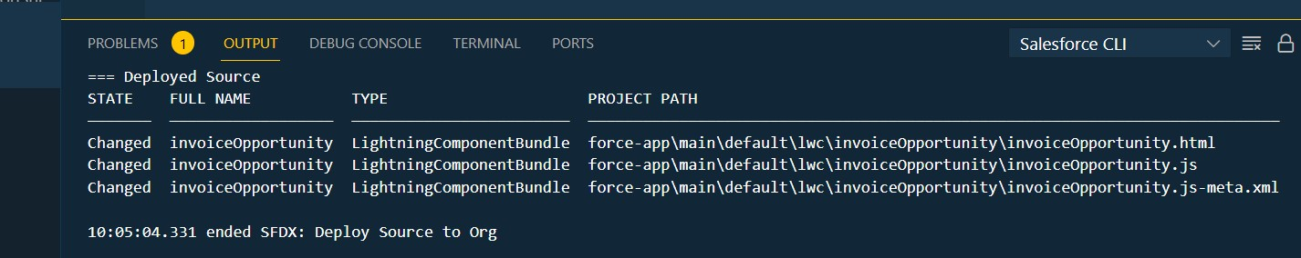

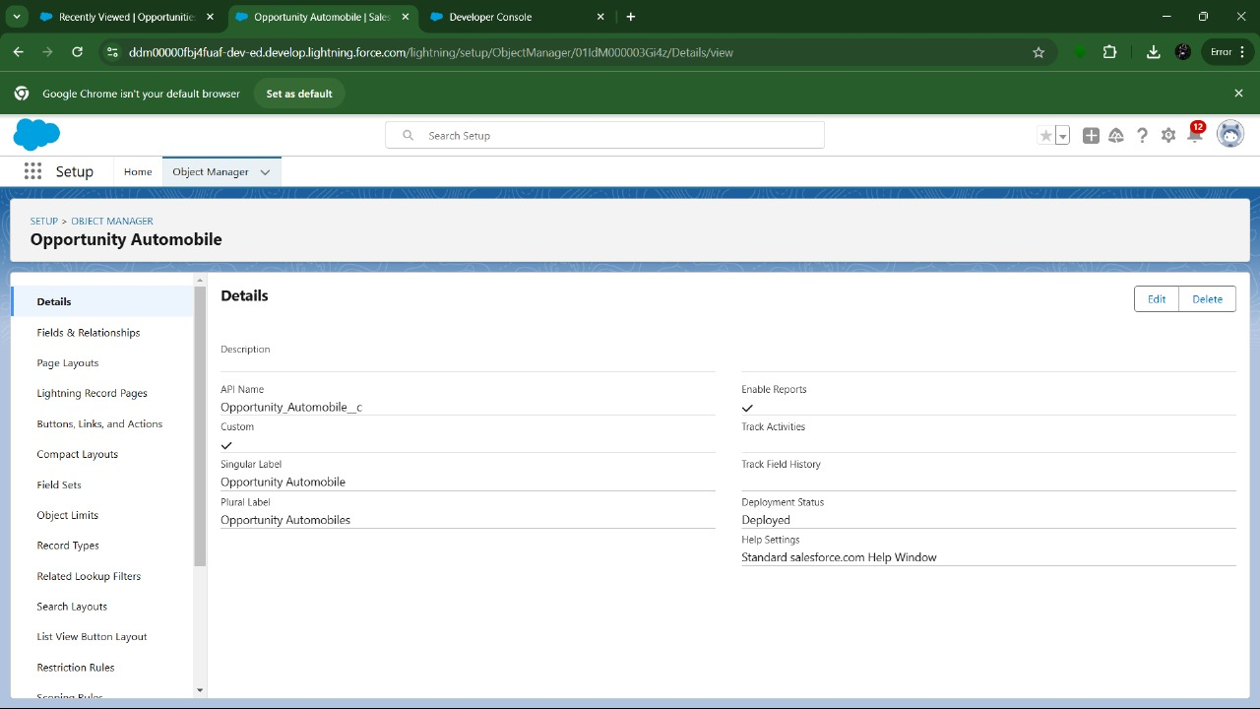

1. Click on Mobile And Lightning Action as show on below Image
2. Search for invoice on Quick Find.

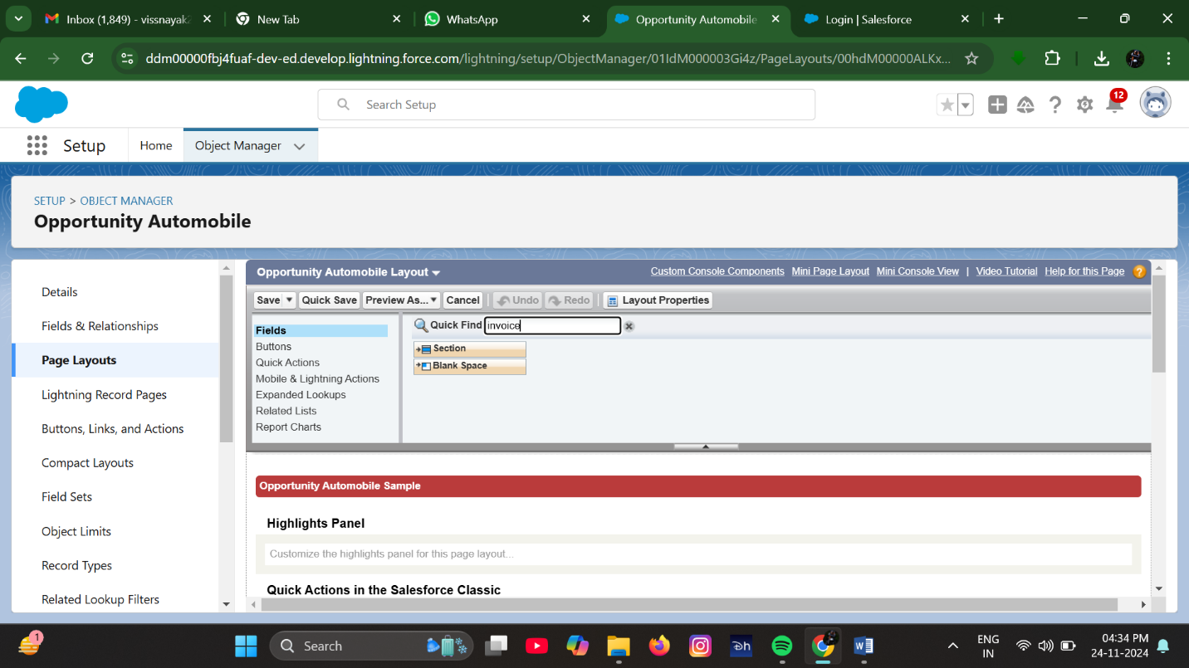

1. Drag and Drop the Invoice into Salesforce Mobile and Lightning Experience Actions.

**Milestone 9 : Apex Schedulers :**

The Apex Scheduler lets you delay execution so that you can run Apex classes at a specified time. This is ideal for daily or weekly maintenance tasks using Batch Apex. To take advantage of the scheduler, write an Apex class that implements the Schedulable interface, and then schedule it for execution on a specific schedule.

**Schedulable Apex Syntax :**

To invoke Apex classes to run at specific times, first implement the Schedulable interface for the class. Then, schedule an instance of the class to run at a specific time using the System.schedule() method.

After you implement a class with the Schedulable interface, use the System.schedule() method to execute it. The System.schedule() method uses the user's timezone for the basis of all schedules, but runs in system mode—all classes are executed, whether or not the user has permission to execute the class.

**Objective :**

* Through this schedulable class, we can see all the Closed Lost Opportunities.
* We can delete all the Closed lost Opportunities by this Scheduled method on every monday as weekly.
  1. Login to the respective account and navigate to the gear icon in the top right corner.
  2. Click on the Developer console. Now you will see a new console window.
  3. In the toolbar, you can see FILE. Click on it and navigate to new and create New apex class.
  4. Name the class as “DeleteClosedLostOpportunities ”

**CODE SNIPPET :**

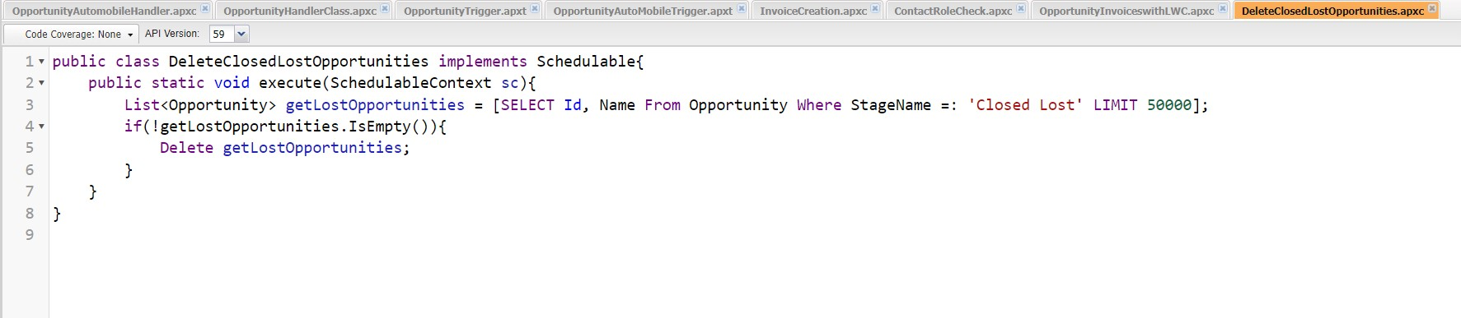

**Schedule the Apex class:**

* We are go to the Home page in your salesforce account.
* In the search bar, enter Apex and click on Apex Classes.

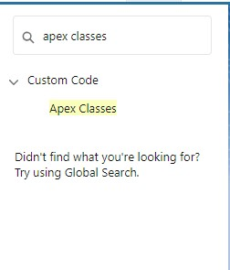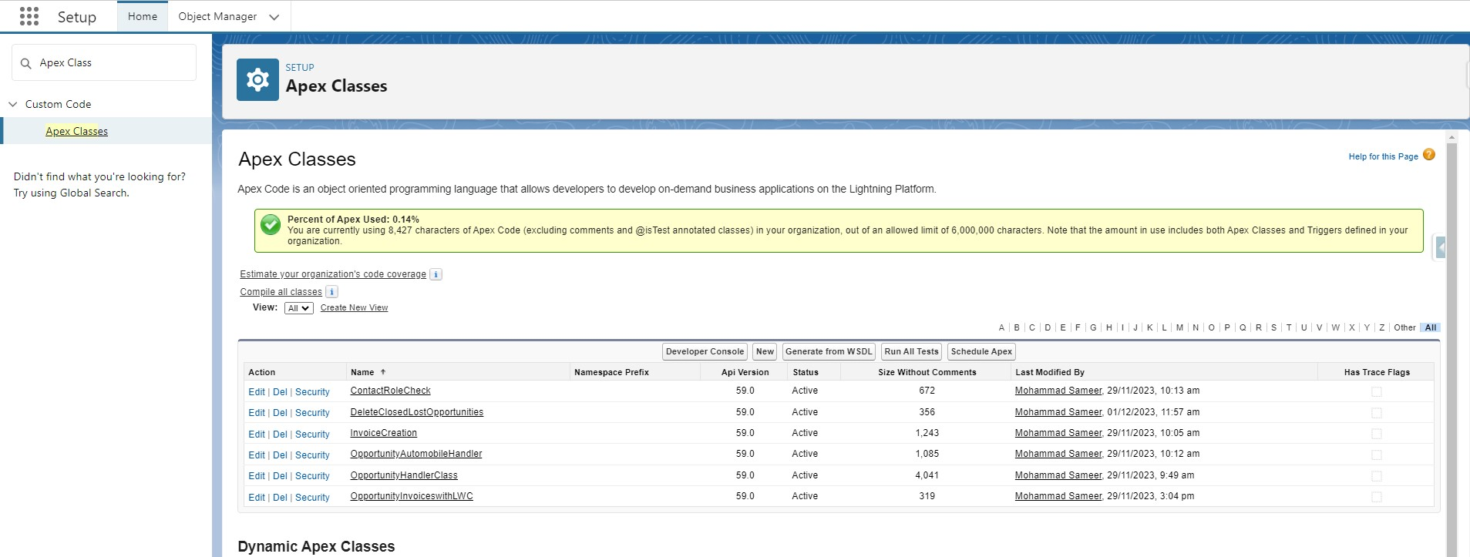

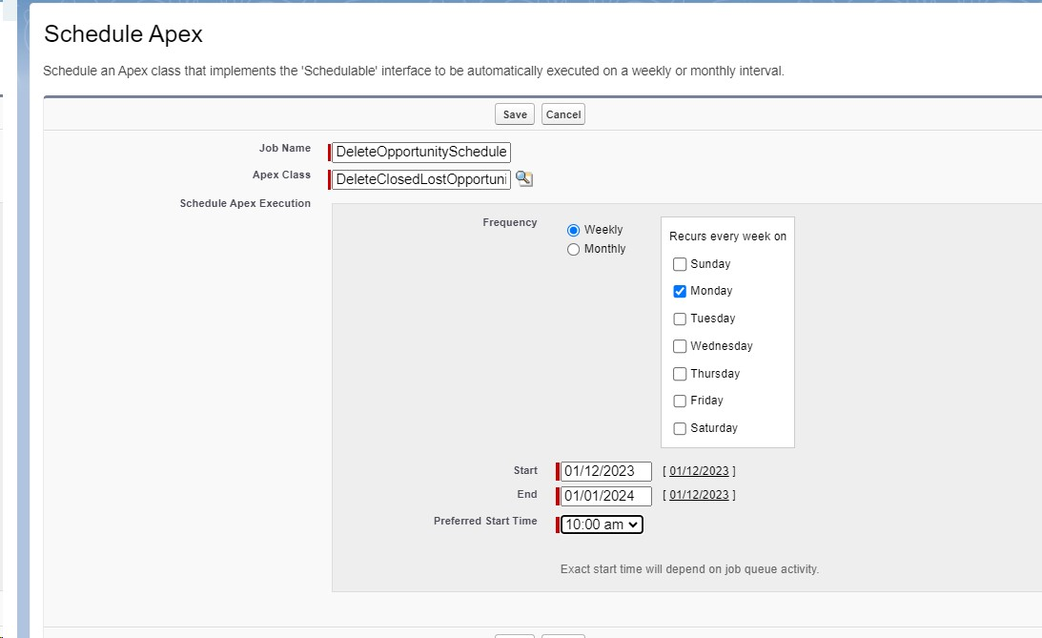

1. Now click on the search icon present near the Apex class : Goto the Lookup icon beside → click on it → select DeleteClosedLostOpportunities.

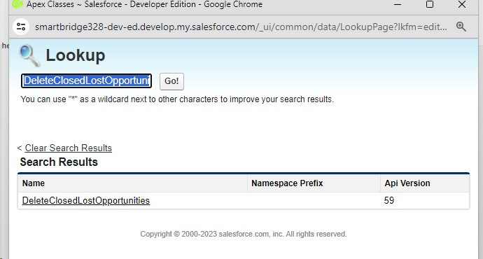

1. In the Schedule Apex section , select weekly and select Monday mentioned and preferred time as 10:00 AM.



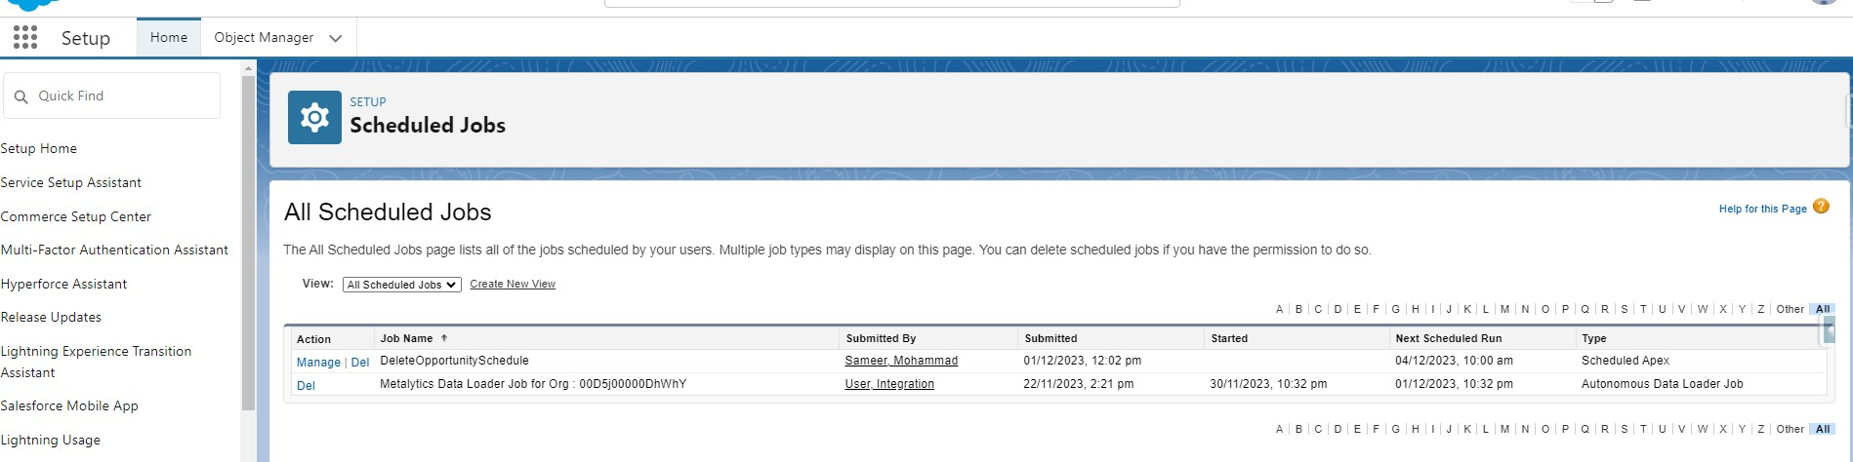

You can see that the batch job is in queue and will run whenever the day mentioned comes.

**Milestone 10 : Reports:**

Reports give you access to your Salesforce data. You can examine your Salesforce data in almost infinite combinations, display it in easy-to-understand formats, and share the resulting insights with others. Before building, reading, and sharing reports, review these reporting basics.

Types of Reports in Salesforce

1. Tabular
2. Summary
3. Matrix
4. Joined Reports Use Case:

The CEO of an organization wants to have brief data on Opportunity Sales along with Invoices generated.

Let’s create a Report.

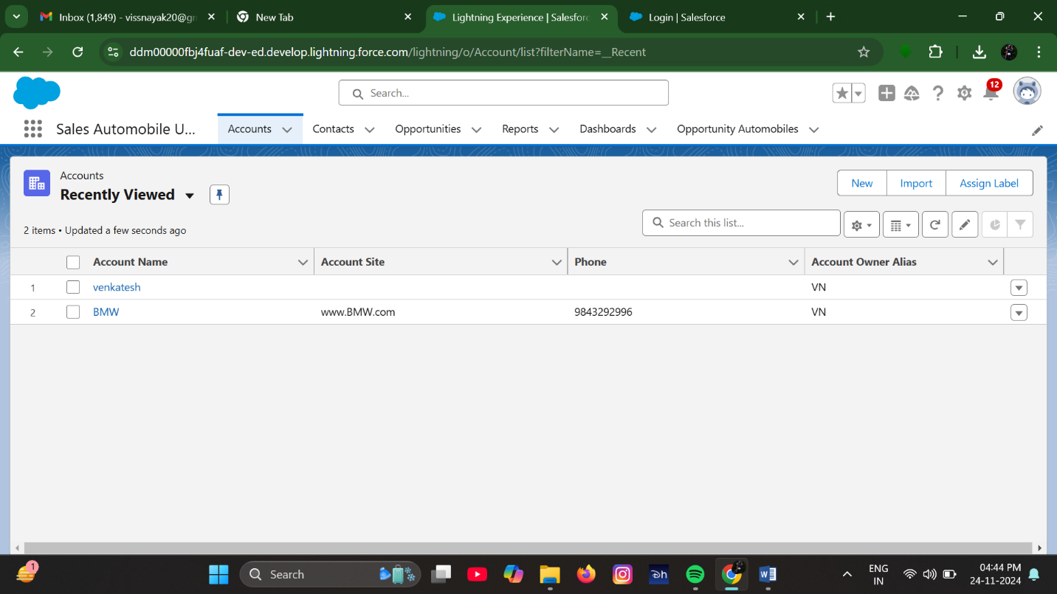

Add the Above Filter as well.

Note: Reports may get varied from the above pictures as the data might be different.

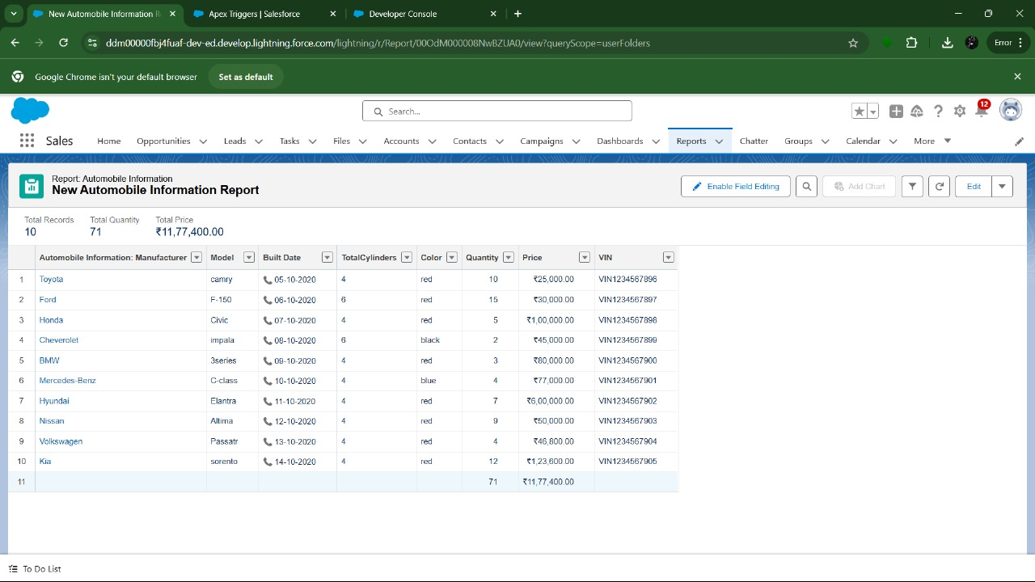

1. Create a Report by using “Opportunities with Opportunity Automobiles and Automobile” Report Type.

**Milestone 11 :Dashboard:**

Dashboards help you visually understand changing business conditions so you can make decisions based on the real-time data you’ve gathered with reports. Use dashboards to help users identify trends, sort out quantities, and measure the impact of their activities. Before building, reading, and sharing dashboards, review these dashboard basics.

Use Case:

As an Admin for the organization you keep pushing yourself to reach out the business requirements to take the organization to peak heights and all your superiors are very much impressed with your efforts and work dedication. In addition with reports you make an ease for the CEO in viewing the reports with data visualization. So he doesn't have to search for the data he wants during the meetings.

Activity 1:

Create Dashboard

1. We are go to the app → click on the Dashboards tabs.
2. Give a Name and click on Create.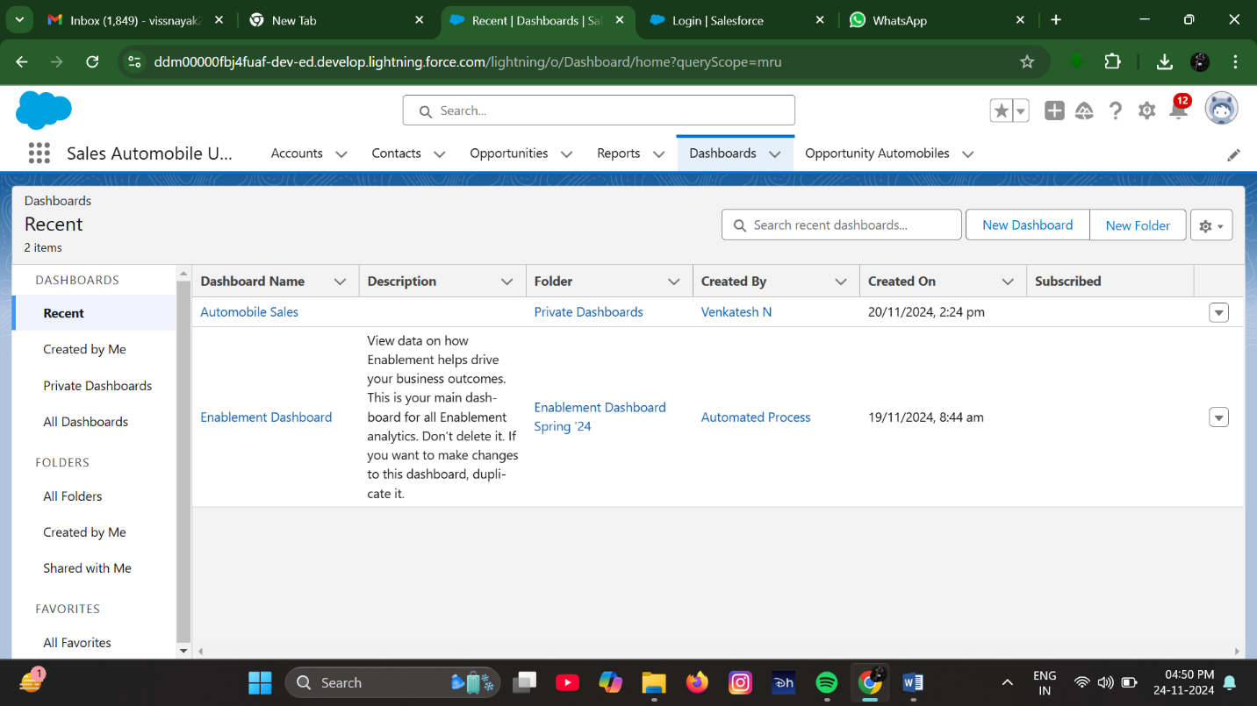

Name : Automobile Sales

1. Select add component.

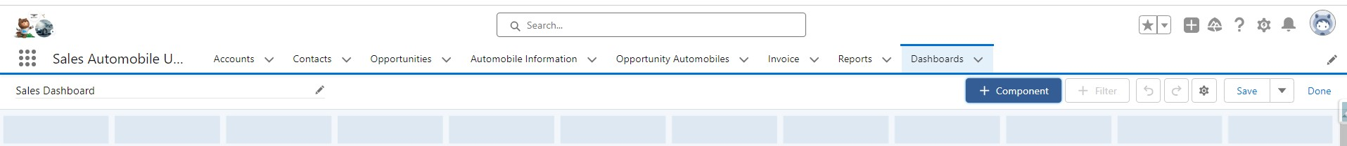

1. Select a Report and click on select.

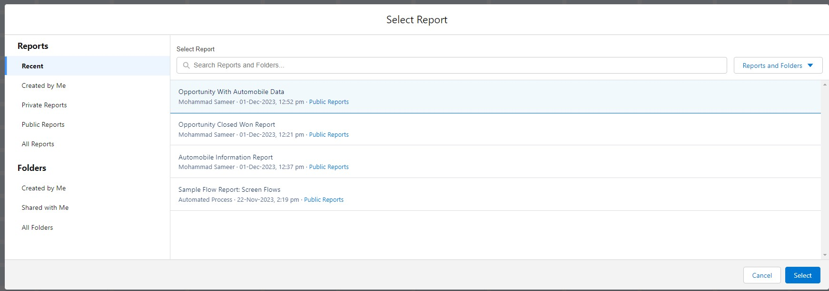

*******************************END****************************